LIMIT REFERENCE POINTS AND WILD SALMON POLICY RAPID STATUS SUMMARY:

2023 FRASER – EARLY SUMMER RUN SOCKEYE STOCK MANAGEMENT UNIT

Executive Summary
There are nine CUs in the Fraser Early Summer (ES) Run Sockeye SMU and they are designed as 2 Red, 6 Amber, and 1 Unknown, placing this SMU below the LRP in terms of the 2022 WSP rapid statuses (Figures 1-17 & Table 3).
The Bowron-ES CU was assessed as Red based on its recent generational average (1,696) being below the lower benchmark of 5,047. It’s prior integrated status from 2015 was also Red.
The Nahatlatch-ES CU was assessed as Amber based on its recent generational average (4,352) being above 1,500 spawners and being greater than 79% Long-Term trend (80%). It’s prior integrated status from 2015 was also Amber.
The Shuswap-ES CU was assessed as Amber based on its recent dominant cycle abundance (79,625) being between its lower and upper Relative-Abundance thresholds (36,380-155,921). It’s prior integrated status from 2015 was also Amber.
The North Barriere-ES CU was assessed as Amber based on its recent generational average (1,741) being above 1,500 spawners and above the lower benchmark of 640. It’s prior integrated status from 2015 was Amber, with the Rapid Status picking up a shift to Red in 2018 until 2022.
The Chilliwack-ES CU was assessed as Red based on its recent generational average (5,536) being below its lower Relative-Abundance threshold (8,000). It’s prior integrated status from 2015 was Amber-Green. The Rapid Status picked up a shift to Red in 2018.
The Anderson-Seton-ES CU was assessed as Amber based on its recent generational average (9,330) being above its Relative-Abundance threshold (3,662) but below the upper Absolute-Abundance threshold (10,000). It’s prior integrated status from 2015 was Amber-Green.
The Nadina-Francois-ES CU was assessed as Amber based on its recent generational average (51,856) being between its lower and upper Relative-Abundance thresholds (21,694-75,100). It’s prior integrated status from 2015 was Amber-Green.
The Pitt-ES CU was assessed as Amber based on its recent generational average (16,897) being between its lower and upper Relative-Abundance thresholds (6,240-22,366). It’s prior integrated status from 2015 was Green. The Rapid Status picked up a shift to Amber in 2019.
The Taseko-ES CU was assessed as NA based on recent data deficiencies. Its recent average would be below 1,500 spawners and place it in the Red status, but there are only three years of recent data because there is a gap in assessment (2019). It’s prior integrated status from 2015 was Red. It is recommended to continue to treat this CU as Red.

Context
A key recommendation from a CSAS peer review process on Pacific Salmon Limit Reference Points (LRPs) is ‘CU [conservation-unit] status-based LRPs’ be used to meet the Fish Stocks provisions of the Fisheries Act (DFO 2022; Holt et al. 2023a, 2023b), which was supported nationally (DFO 2023). LRP's are assessed for Stock Management Units (SMUs), which can include one or more conservation units (CUs) (i.e., CUs are nested within SMUs). Using this approach, serious harm to a SMU is identified when any component CU zone drops into the Wild Salmon Policy (WSP) Red zone. Under this definition, the CU status-LRP is ‘100% of CUs with statuses above Red status’. The implications are that if a single CU is the Red status zone, the SMU is assessed as being below its LRP, which in turn triggers a DFO rebuilding plan for the SMU.

Forewords
Please fill in with perspectives or values that are not captured through the Rapid Status Assessment algorithm. Include whom the forewords should be attributed to (may be a group or individuals).

Data
The Fraser – Early Summer Run Sockeye SMU is comprised of five non-cyclic CUs (Bowron-ES; Nahatlatch-ES; North Barriere-ES; Anderson-Seton-ES; Nadina-Francois-ES; Pitt-ES; Taseko-ES) with a combined 11 streams (or shorelines) that were used in the assessment and two cyclic CU (Shuswap-ES; Chilliwack-ES) with 6 streams (or shorelines) used in its assessment (Table 1). The data used in this assessment were described in detail in Grant et al. (2011), Grant & Pestal (2012), and Grant et al. (2020). The last integrated status assessments for these CUs occurred for return year 2017 (Grant et al. 2020). Some of the data was also recently used in the Fraser Sockeye Recovery Potential Assessments (Huang et al. 2021; Doutaz et al. 2023).
The primary forms of spawner enumeration surveys vary across the CUs in this SMU. Early Bowron-ES data was collected by fixed-site census (fence) and then has primarily been visual surveys. Nahatlatch-ES data was primarily collected through visual survey methods. North Barriere-ES data has primarily been collected through visual surveys with a period of time collected by fixed-site census. Anderson-Seton-ES data has primarily been collected by fixed-site census at the spawning channel and otherwise by visual surveys. Nadina-Francois-ES data primarily been collected through a combination of fixed-site census and visual methods and most recently a mix of fixed-site census and SONAR methods. Pitt-ES data was primarily collected through mark-recapture methods but shifted to visual methods in the 2010s. Chilliwack-ES data is primarily collected with SONAR during large returns and visual methods otherwise. Taseko-ES data was collected by mark-recapture methods in the 1950s-70s but then the survey coverage becomes patchy. Taseko-ES was then was collected using visual methods (primarily Lake expansions) and then most recently (since 2021) has been collected by SONAR methods.
When spawner abundance is forecasted to be greater than 75,000, then one of the higher precision methods (mark-recapture, fixed-cite census, SONAR) are normally implemented. The timeseries for these CUs start as early as 1950, and for this assessment, end with data from 2022.
Key steps in the data processing of this data set includes stream selection, gap infilling, and assessing data quality, which are described in detail in Grant et al. (2011). Streams were selected for inclusion in the assessment if they were surveyed for >70% of the historical time series. Missing stream-years for CUs with multiple sites were gap filled using a cyclic-specific (or non-specific if non cyclical) mean proportion approach, which leverages spatially proximate and correlated system’s abundance. Missing stream-years for CUs with single sites used cycle (or generational for non-cyclic) averages from adjacent generations. Data quality is assessed based on the number and completeness of surveys, coverage of the spawning period, visibility and reliability records, and methodology.
The average spawner data quality of Shuswap-ES, Pitt-ES CUs is considered “very good” and Bowron-ES, North Barriere-ES, Anderson-Seton-ES, Nadina-Francois-ES is considered “good” and representative of the total CU abundance (Grant et al. 2020). The CU data for the former mentioned CUs are treated as absolute abundance that can be used in the absolute abundance and relative abundance-based benchmark metrics. The data quality of Nahatlatch-ES was considered “good” and appropriate to be used in the absolute abundance metric but no recruitment data is available to develop relative abundance-based benchmark metrics. The data quality of Chilliwack-ES was considered “good” and appropriate to be used in both the absolute abundance and relative-abundance metrics, but the time-series was too short to estimate relative-abundance benchmarks in the same way as the other CUs. The Taseko-ES data was only considered to be “fair”, there are a limited number of years, and no recruitment data is available. Most of the timeseries data is considered as a relative-abundance index and is not appropriate to compare against absolute or relative-abundance based benchmarks. No relative-abundance based benchmarks exist for Taseko as well.
Relative Abundance Benchmarks:
Relative-abundance based benchmarks for all of the non-cyclic CUs, with the exception of Nahatlatch-ES and Taseko-ES, in this SMU were developed using Ricker Stock-Recruit models (Grant et al. 2020). Benchmarks for each CU were last updated using brood year data up to 2010 (Grant et al. 2020). The 50th percentile and 80 percent interval of Ricker-based benchmarks are presented for each CU (Table 2).
Relative-abundance based benchmarks for Shuswap-ES CU were developed using a Larkin Stock-Recruit model due to it’s cyclic nature (Grant et al. 2020). Benchmarks for each cycle line (one dominant and three weak cycles) were last updated using brood years up to 2010 (Grant et al. 2020). The 50th percentile and 80 percent interval of Larkin-based benchmarks are presented for each cycle line (Table 2). In mimicking the integrated status approach and results, only the dominant cycle brood line is assessed against it’s relative abundance-based benchmark; which then stands as that metric’s result for the subsequent three cycle line’s years. E.g. The most recent dominant cycle line year for Shuswap-ES is 2022. The comparison of the 2023 effective total spawner abundance is compared against it’s dominant cycle specific relative abundance benchmark. The result of this comparison is then used for return years 2022-2025 until the next dominant cycle return in 2026.
Relative-abundance based benchmarks for Chilliwack-ES CU were developed from S_{max} estimates from a lake productivity model Grant et al. 2011; Grant & Pestal 2013) because the stock-recruit time series was too short and their model evaluation was deemed them to be unsuitable (Grant et al. 2020). Therefore, there are no cycle-specific benchmarks.
Table 1. Conservation Units (CUs) included in this Stock Management Unit (SMU) and lists of the streams/populations within each CU used in the Rapid Status Assessment. Streams have their NuSEDS population identifications in brackets.
CU No# | CU Name | Streams (Population ID) | Timeseries
SEL-07-01 | Bowron-ES | Bowron River, upper (47419)  Huckey Creek (3219)  Pomeroy Creek (3220) | 1955-2023
SEL-05-02 | Nahatlatch-ES | Nahatlatch Lake (45094)  Nahatlatch River (47157) | 1975-2023
SEL-09-02 | Shuswap-ES | McNomee Creek (45014)  Scotch Creek (46288)  Seymour River (46328) | 1950-2023
SEL-10-03 | North Barriere-ES | Barriere River, upper (3416) | 1967-2023
SEL-03-01 | Chilliwack-ES | Chilliwack Lake (45092)  Chilliwack River, upper (46986) | 2001-2023
SEL-06-01 | Anderson-Seton-ES | Gates Channel (45102)  Gates River (47211) | 1950-2023
SEL-06-20 | Nadina-Francois-ES | Late Nadina Channel (45525)  Late Nadina River (45525) | 1973-2023
SEL-03-05 | Pitt-ES | Upper Pitt River (47917) | 1950-2023
SEL-06-16 | Taseko-ES | Taseko Lake (46853) | ~1994-2018 / 2020-2023

Table 2. Relative abundance-based benchmarks and credible intervals by Conservation Unit (CU) and Cycle Line. The upper benchmarks are 80% S_{MSY} and the lower benchmarks are S_{gen}. Values were estimated in Grant et al. (2020). *Denotes the Dominant Cycle Line, which is used in the Rapid Status Assessment. Upper Benchmarks are multiplied by 1.1 in the algorithm.
CU Name | Cycle Line Recent Year | Benchmark | p50 | Credible Interval (p10-p90)
Bowron-ES | - | 80% S_{MSY} | 19,369 | 14,610 – 26,966
Bowron-ES | - | S_{gen} | 5,249 | 3,619 – 7,856
Nahatlatch-ES | - | No Upper | - | -
Nahatlatch-ES | - | No Lower | - | -
Shuswap-ES | 2022* | 80% S_{MSY} | 141,746 | 95,945 – 264,455
Shuswap-ES | 2022* | S_{gen} | 36,380 | 22,616 – 73,780
North Barriere-ES | - | 80% S_{MSY} | 5,097 | 4,260 – 6,403
North Barriere-ES | - | S_{gen} | 640 | 427 – 1,019
Chilliwack-ES | - | 80% S_{MSY} | 16,000 | 14,000 – 18,000¹
Chilliwack-Es | - | S_{gen} | 8,000 | 6,000 – 10,000¹
Anderson-Seton-ES | - | 80% S_{MSY} | 22,534 | 12,802 – 63,588
Anderson-Seton-ES | - | S_{gen} | 3,662 | 1,747 – 12,222
Nadina-Francois-ES | - | 80% S_{MSY} | 68,273 | 33,966 – 220,053
Nadina-Francois-ES | - | S_{gen} | 21,6940 | 9,391 – 77,505
Pitt-ES | - | 80% S_{MSY} | 26,845 | 21,990 – 35,263
Pitt-ES | - | S_{gen} | 10,627 | 7,450 – 16,112
Taseko-ES | - | No Upper | - | -
Taseko-ES | - | No Lower | - | -
1-The Credible Interval for Chilliwack-ES is only a 50% interval from p25-p75.

WSP Rapid Status Summary
Stock Management Unit (SMU) Limit Reference Point (LRP) status and narrative based on expert consensus
There are nine CUs in the Fraser Early Summer Run Sockeye SMU and they are designed as 3 Red, 5 Amber, and 1 Unknown, placing this SMU below the LRP in terms of WSP rapid status (Figures 1-17 & Table 3).
Summarize any additional information and comments from the expert review.
The background descriptions of the CUs from the 2017 (Grant et al. 2020) assessments remain appropriate and have been copied for the beginning of each CU’s narrative.

Bowron-ES
Bownron-ES’s expansion after Hells Gate landslide is attributed to remnant Bowron Sockeye (see Grant et al. 2011). Although historically this CU exhibited cyclic dominance (dominant cycle line: 1955), this has not occurred for several decades now. Spawner abundance in the dominant cycle line was high up until the 1980s. Abundance remained moderate through to the early 2000s with only 1995 being comparable in spawner abundance to the historical dominant cycle line abundance. Abundance was relatively low for a whole generation starting in 2004, with the recent generation average remaining below the lower abundance benchmark through till present.
The prior 2015 Integrated Status was Red. There was no change in status in the 2023 Rapid Status, which is Red with High Confidence.

Nahatlatch-ES
Nahatlatch-ES occurs in a relatively remote river system located in a protected BC park. There are no known transplants or major human activities associated with this CU (Grant et al. 2011). This CU includes the Nahatlatch Lake and River populations, since the lake is an index of abundance only, escapements for this CU are biased low but still considered appropriate to measure against the absolute abundance metric.
Spawner abundance initially increased from the beginning of the available time series in 1975 to a maximum spawner estimate in 1988. Spawner abundance has generally decreased since then with variable increases and decreases throughout the time series. There was a particularly low period just before 2010, which resulted in the geometric average dropping below 1,500 and another low period between 2016-2020 where the geometric average dropped below 1,500 between 2019-2021.
The prior 2015 Integrated Status was Amber. There was no change in status in the 2022 Rapid Status, which is Amber with Medium Confidence.

Shuswap-ES
Within Shuswap-ES, Scotch Creek was enhanced on the cycle line coinciding with the dominant Adams River cycle using Seymour Creek as a donor stock; as a result, the Scotch Creek population started to build in the 1980’s. Seymour was frequently used as a hatchery donor population for other CUs (Grant et al. 2011).
Spawner abundance was generally low in the timeseries up until 1986, when the dominant cycle abundance reached above the upper relative-abundance benchmark for the first time. There were two lower returns of the dominant cycle in 1994 and 1998 followed by a period where the abundance was above the upper benchmark until the return in 2022, when it fell back below the upper benchmark but still remains above the lower benchmark.
The prior 2015 Integrated Status was Amber. There was no change in status in the 2023 Rapid Status, which is Amber with High Confidence.

North-Barriere-ES
The original North Barriere-ES CU was extirpated by the construction of a downstream dam. With the combination of dam removal and hatchery transplants, this population was re-established (Grant et al. 2011). Only data post-1970, after this CU started to re-build, was used in the status evaluation.
The generational geometric average spawner abundance rose to above the upper relative-abundance benchmark in 1988, with a maximum spawner abundance observed in 1996; after which, abundance has generally been declining. The geometric average spawner abundance has remained below the upper benchmark but above the lower benchmark since 2008; however, it has dropped below 1,500 total effective spawners since 2018.
The prior 2015 Integrated Status was Amber. There was a reduction in status in the 2022 Rapid Status, which is Red with High Confidence. In 2023, the Rapid Status again reverted to Amber with High Confidence as the recent generational average was above 1,500 and above the lower benchmark.

Chilliwack-ES
Complete escapement assessments of this CU did not begin until 2001; prior to this year, the Upper Chilliwack River (Dolly Varden Creek) was not assessed in its entirety. Therefore, for consistency, this time series only includes 2001 to present.
Chilliwack-ES geometric average spawner abundance has remained relatively stable compared to other CUs but has dipped in the late 2000s and recently since 2017. The dominant cycle line remains above the upper relative-abundance benchmark, with the highest observation occurring in 2012. However, because there are no cycle-specific benchmarks, this CU’s relative abundance metric is compared to the generational geometric average, which includes all cycle lines. The average spawner abundance has remained below the lower benchmark since 2018.
The prior 2015 Integrated Status was Amber-Green. There was a reduction in status in the 2023 Rapid Status, which is Red with High Confidence.

Anderson-Seton-ES
Forest harvesting and other human activities were believed to have deteriorated habitat quality prior to the 1960’s, as a result, a channel was constructed between 1967-1968 to compensate for this loss to production; the channel accounted for a high proportion of this CU’s production but has been discontinued since 2020. Both Gates Creek and the Channel are included in the escapement time series for status evaluations. These Sockeye must migrate through a hydroelectric facility, which can challenge migration (Grant et al. 2011). Although historically this CU exhibited cyclic dominance (dominant cycle line: 1956), this has not occurred since 2000.
The geometric average spawner abundance of Anderson-Seton-ES began increasing in the late 1970s to an initial peak around 1990. There was a subsequent step-like general decrease up to 2010. The two highest spawner abundances in the time series then occurred in 2011 and 2013; which were then followed by a general decline in the geometric average. The geometric average spawner abundance has primarily remained within the bounds between the lower and upper relative-abundance benchmarks since 1986.
The prior 2015 Integrated Status was Amber-Green. There was a slight reduction in status in the 2023 Rapid Status, which is Amber with High Confidence.

Nadina-Francois-ES
Nadina-Francois-ES CU has undergone several changes to its composition through time. Most notable have been the aggregation of a “first” and “second” run and the transition from it being a cyclic population to a non-cyclic population (Grant et al. 2020). Additionally, a spawning channel was completed in 1973 as a response to habitat loss caused by historical log driving on the Nadina River (discontinued in 1968). Only spawner abundance from after the construction of a spawning channel is considered in the assessment.
The generational geometric average spawner abundance remained below the lower relative-abundance benchmark until 2015 with only one notably high individual-year return in 2000. The spawner abundance has generally increased and stayed above the lower benchmark with the exception of 2017. There was a record high individual-year spawner estimate in 2022. The geometric average has never surpassed the upper relative-abundance benchmark.
The prior 2015 Integrated Status was Amber-Green. There was a slight reduction in status in the 2023 Rapid Status, which is Amber with High Confidence.

Pitt-ES
This CU is supplemented with hatchery produced fry releases (Pitt Sockeye origin). Since these hatchery-origin sockeye are not externally marked, it is unclear how this supplementation influences the stock-recruitment time series (Grant et al. 2011).
The generational geometric average spawner abundance of Pitt-ES was generally lower before 1996, mostly remaining below the upper relative-abundance benchmark but always above the lower benchmark. Since 1996, Pitt-ES exceeded the upper relative-abundance benchmark , peaking in abundance in 2001. Abundance has fluctuated within the green zone but a decrease occurred starting in 2018, which has resulted in the average abundance dropping below the upper relative-abundance benchmark since 2019.
The prior 2015 Integrated Status was Green. There was a reduction in status in the 2023 Rapid Status, which is Amber with High Confidence.

Taseko-ES
Taseko-ES sockeye reside in a glacially influenced lake that is highly turbid. Historical escapement estimates are based on visual surveys of carcasses in the lake, expanded by survey effort, which are likely biased low and represent an index of spawning abundances only (see Grant et al. 2011). Grizzly bear abundance also has a large effect on the probability of recovering carcasses during assessment surveys, which further confounds the accuracy of estimates. There have been recent efforts to apply SONAR methods to improve the estimate accuracy. Further research is planned to continue SONAR methodology and investigate the potential of calibrating historical estimates. Additionally, the assessment in 2019 was unsuccessful due to logistical complications from the Big Bar landslide and the year has not been infilled as no appropriate method has been identified to do so given the uncertainty of the historical data.
The historical integrated assessments (up to 2010 and 2015 return years) have both determined that Taseko-ES CU is Red status under the WSP. The 2021, 2022, and 2023 SONAR based estimates have been 1307, 1913, and 1992 respectively, which would be a geometric average of 1708 (noting only 3 years, not a full generational average). The 2024 return was heavily impacted by a landslide in the Chilcotin River around the timing of their migration. Preliminary estimates of the 2024 return indicate that the spawner abundance was well below 1000. The last year when the Rapid-Status Algorithm was run on the historical data, 2018, indicated that the status should still be Red.
It is recommended that the previous integrated status of Red be upheld considering that the most recent available Rapid-status was also Red and that the return in 2024 is well below 1000.
Reference the list of meetings and contributors can be found in Appendix 2
Future work: Please fill in with future works that were suggested by subject matter experts with regards to assessing population status.

Table 3. Wild Salmon Policy (WSP) Rapid Statuses for [insert final data year]. For background, refer to Appendix 1.
CU # | CU Name | WSP Rapid Status (2022) | WSP Rapid Status Node and Pathway
SEL-07-01 | Bowron-ES | RED,  HIGH | The recent year’s status (2023) is designated Red with a high confidence based on the algorithm. The data could be assessed as Absolute Abundance. The recent generational average is 1,696 spawners, and is above the lower absolute-abundance threshold of 1,500 but below the lower benchmark of 5,047 (Node 23, Figure 2, Table 4). This Red status has been variable throughout the status time series from 1995 to 2022 (Figure 1). The 2015 WSP rapid status of Red matches the WSP integrated status of Red from 2015 (DFO 2020). Although not used in the status determination, the Long-term Trend indicates that the spawner abundance has been below half of the long-term average since 2007 and the recent three generations have been in the Red zone of the Percent-Change metric.
SEL-05-02 | Nahatlatch-ES | AMBER, MODERATE | The recent year’s status (2023) is designated Amber with a moderate confidence based on the algorithm. The data could be assessed as Absolute Abundance. The recent generational average is 4,352 spawners, which is below the upper Absolute-Abundance threshold of 10,000. There are no Relative-Abundance benchmarks, so the Long-term Trend Metric was used to determine status. The Long-term trend, 80%, was greater than the 79% lower threshold (Node 20, Figure 4, Table 5). This status has been variable throughout the status time series from 1995 to 2023 (Figure 3), with three years of Red status recently in 2019-2021 due to the Long-term Trend dropping below 79%. The 2015 WSP rapid status of Amber does match the WSP integrated status of Amber in 2015 (DFO 2020).
SEL-09-02 | Shuswap-ES | AMBER, HIGH | The recent year’s status (2023) is designated Amber with a high confidence based on the algorithm. The data could be assessed as Absolute Abundance. The recent generational average is 14,275, which is above the upper Absolute-Abundance threshold. The recent dominant cycle return is 79,625 spawners, and is above the lower Relative-Abundance threshold of 36,380 but below the upper threshold of 155,921 (Node 37, Figure 6, Table 6). This Amber status has been variable throughout the status time series from 1995 to 2023 (Figure 5), switching from Green to Amber in 2019-2020 and back to green in 2021. The 2015 WSP rapid status of Green does not match the WSP integrated status of Amber from 2015 (DFO 2020).
SEL-10-03 | North Barriere-ES | AMBER, HIGH | The recent year’s status (2023) is designated Red with a high confidence based on the algorithm. The data could be assessed as Absolute Abundance. The recent generational average is 1,741 spawners, and is above the lower Absolute-Abudance Threshold of 1,500 and above the lower benchmark of 640. This Amber status has been variable throughout the status time series from 1995 to 2023 (Figure 4), with abundance primarily being Amber between 2000-2017, and Red afterwards. The 2015 WSP rapid status of Amber matches the WSP integrated status of Amber from 2015 (DFO 2020). The Percent-Change has indicated declining abundance since 2000 and the Long-Term Trend has recently gone below 50%.
SEL-03-01 | Chilliwack-ES | RED, HIGH | The recent year’s status (2023) is designated Red with a high confidence based on the algorithm. The data could be assessed as Absolute Abundance. The recent generational average is 5,536 spawners, and is below the lower Relative-Abundance threshold of 8,000 (Node 23 and Figure 10, Table 8). This Red status has been variable throughout the status time series from 2004 to 2023 (Figure 9), switching between Red from 2005-2011 to Amber in 2012-2017 then back to Red. The 2015 WSP rapid status of Amber is the more precautionary of the WSP integrated status of Amber-Green from 2015 (DFO 2020). Although not used in status determination, the recent Percent-Change metric indicates that the abundance has recently declined.
SEL-06-01 | Anderson-Seton-ES | AMBER, HIGH | The recent year’s status (2023) is designated Amber with a high confidence based on the algorithm. The data could be assessed as Absolute Abundance. The recent generational average is 9,330 spawners, and is above the lower Relative-Abundance threshold of 3,662 but below the upper Absolute-Abundance threshold of 10,000, (Node 22; Figure 12, Table 9). This Amber status has been fairly consistent with one year dropping to Red status throughout the status time series from 1995 to 2022 (Figure 11). The 2015 WSP rapid status of Amber is more precautions than the WSP integrated status from 2015 (DFO 2020) of Amber-Green. It should be noted that the spawning channel was discontinued in 2021. Although not used in this status determination, the Percent-Change in the last two years have indicated a decline in abundance that may need to be monitored.
SEL-06-20 | Nadina-Francois-ES | AMBER,HIGH | The recent year’s status (2023) is designated Amber with a high confidence based on the algorithm. The data could be assessed as Absolute Abundance. The recent generational average 51,856 spawners, and is above the lower Relative-Abundance threshold of of 21,694 but below the upper Relative-Abundance threshold of 75,100, (Node 37; Figure 14, Table 10). This Amber status has been variable throughout the status time series from 1995 to 2023 (Figure 13), primarily Red until 2015, after which, it has been Amber with the exception of one more Red status in 207. The 2015 WSP rapid status of Amber is the more precautionary of the WSP integrated status from 2015 (DFO 2020) of Amber-Green. Although not used in this status determination, both the Percent-Change and Long-term Trend metrics are showing positive trajectories.
SEL-03-05 | Pitt-ES | AMBER, HIGH | The recent year’s status (2023) is designated Amber with a high confidence based on the algorithm. The data could be assessed as Absolute Abundance. The recent generational average is 16,897 spawners, and is above the lower Relative-Abundance threshold of 6,240 and below the upper Relative-Abundance threshold of 22,366 (Node 37; Figure 16, Table 11]. This Amber status has been variable throughout the status time series from 1995 to 2023 (Figure 15), but Amber since 2019. The 2015 WSP rapid status of Green does match the WSP integrated status from 2015 (DFO 2020) where it was designated Green.
SEL-06-16 | Taseko-ES |  | The recent year’s status (2023) is designated as unknown due to a lack of consistent escapement data to run the algorithm. The data could not be assessed as Absolute Abundance (Figure 17). When a status has been able to be calculated across the time series of 1999-2023, it has been consistently red with 2 years of being designated Amber in 2003-2004 by the algorithm (Figure 8). The 2015 WSP rapid status of Red does match the WSP integrated status from 2015 (DFO 2020) of Red. It is believed to still be in this status. Not captured in this assessment, but of note, was a landslide in the Chilcotin River in 2024 that highly impacted Taseko-ES. Preliminary 2024 spawner abundance is much less than 1,000, which would keep the generational geometric average below the lower Absolute-Abundance threshold of 1,500.

SEL-07-01 Bowron-ES
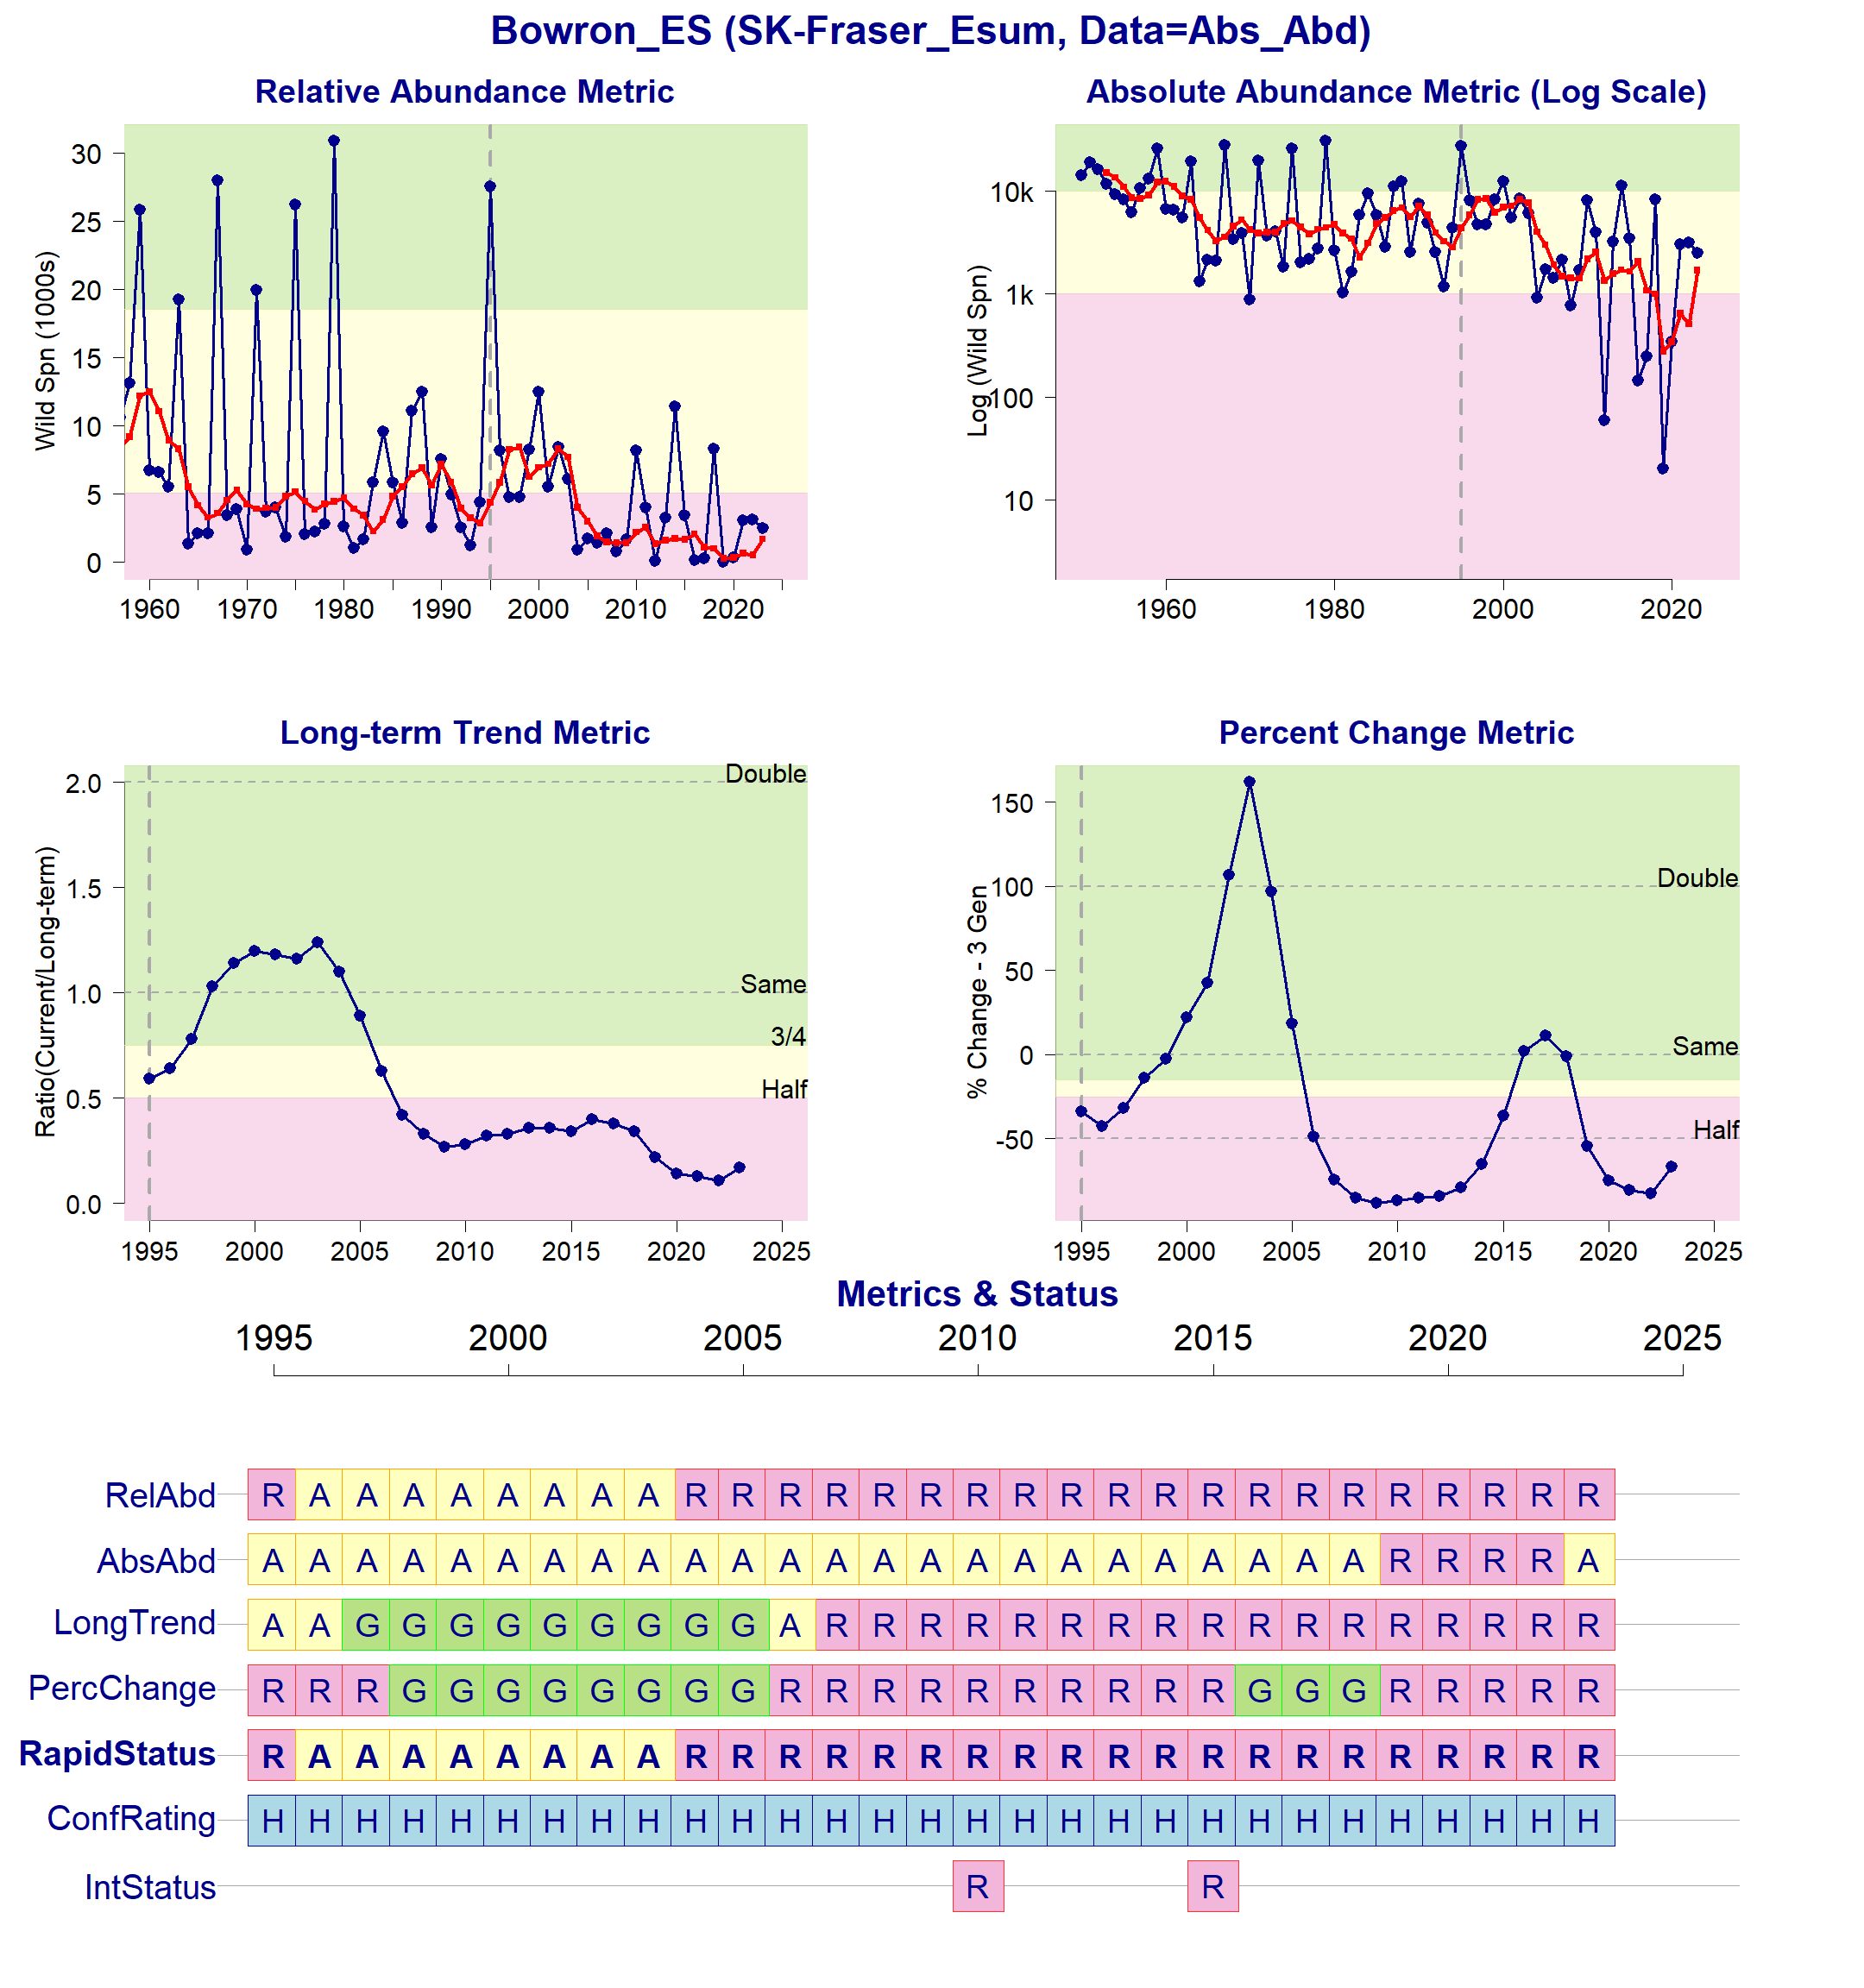
Figure 1: Metrics and Status for Bowron-ES (SEL-07-01). Panels on top show the four standard WSP metrics, calculated based on the available time series of spawner abundances. Bottom panel summarizes the status for each individual metric and shows the resulting WSP rapid status for the CU with a confidence rating. If integrated WSP status assessments have been completed for this CU, they are shown on the last row (IntStatus). Note that metric benchmarks may differ from algorithm thresholds, since thresholds approximate the status determination process from past WSP integrated status assessments (see Figure 2 and Table 4).
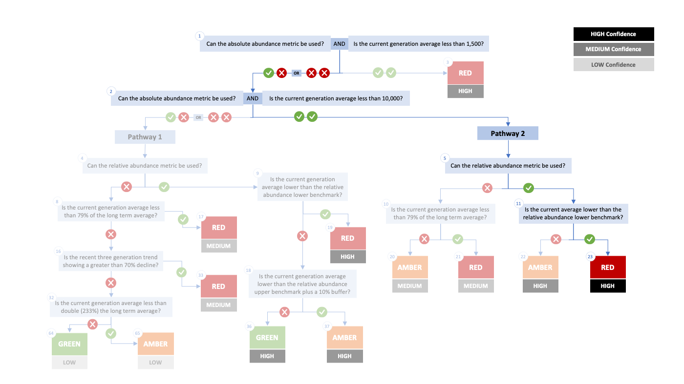
Figure 2. Algorithm pathway taken to assess status for the Bowron-ES in 2023. The recent generational average is above the absolute abundance lower (1,500) threshold but the current average is below the relative abundance lower benchmark. Status for this CU is therefore designated as Red with High confidence at Node 23.
Table 4: Decision tree path given data and metric values for the Bowron-ES in 2023; this aligns with Figure 2 above. For each node, the algorithm decision is made by comparing the CUs current metric value to the metric threshold and answering Yes or No, running through sequential nodes and decisions until the final WSP rapid status for that CU and year is reached.
Node | Metric | Metric Threshold | CU’s Current Value | Decision
1 | Absolute Abundance | <1,500 | 1,696 | YES, NO
2 | Absolute Abundance | <10,000 | 1,696 | YES, YES
5 | Relative Abundance | Available? | - | YES
11 | Relative Abundance | <5,047 | 1,696 | YES
23 | FINAL STATUS NODE | - | - | RED, HIGH

SEL-05-02 Nahatlatch-ES

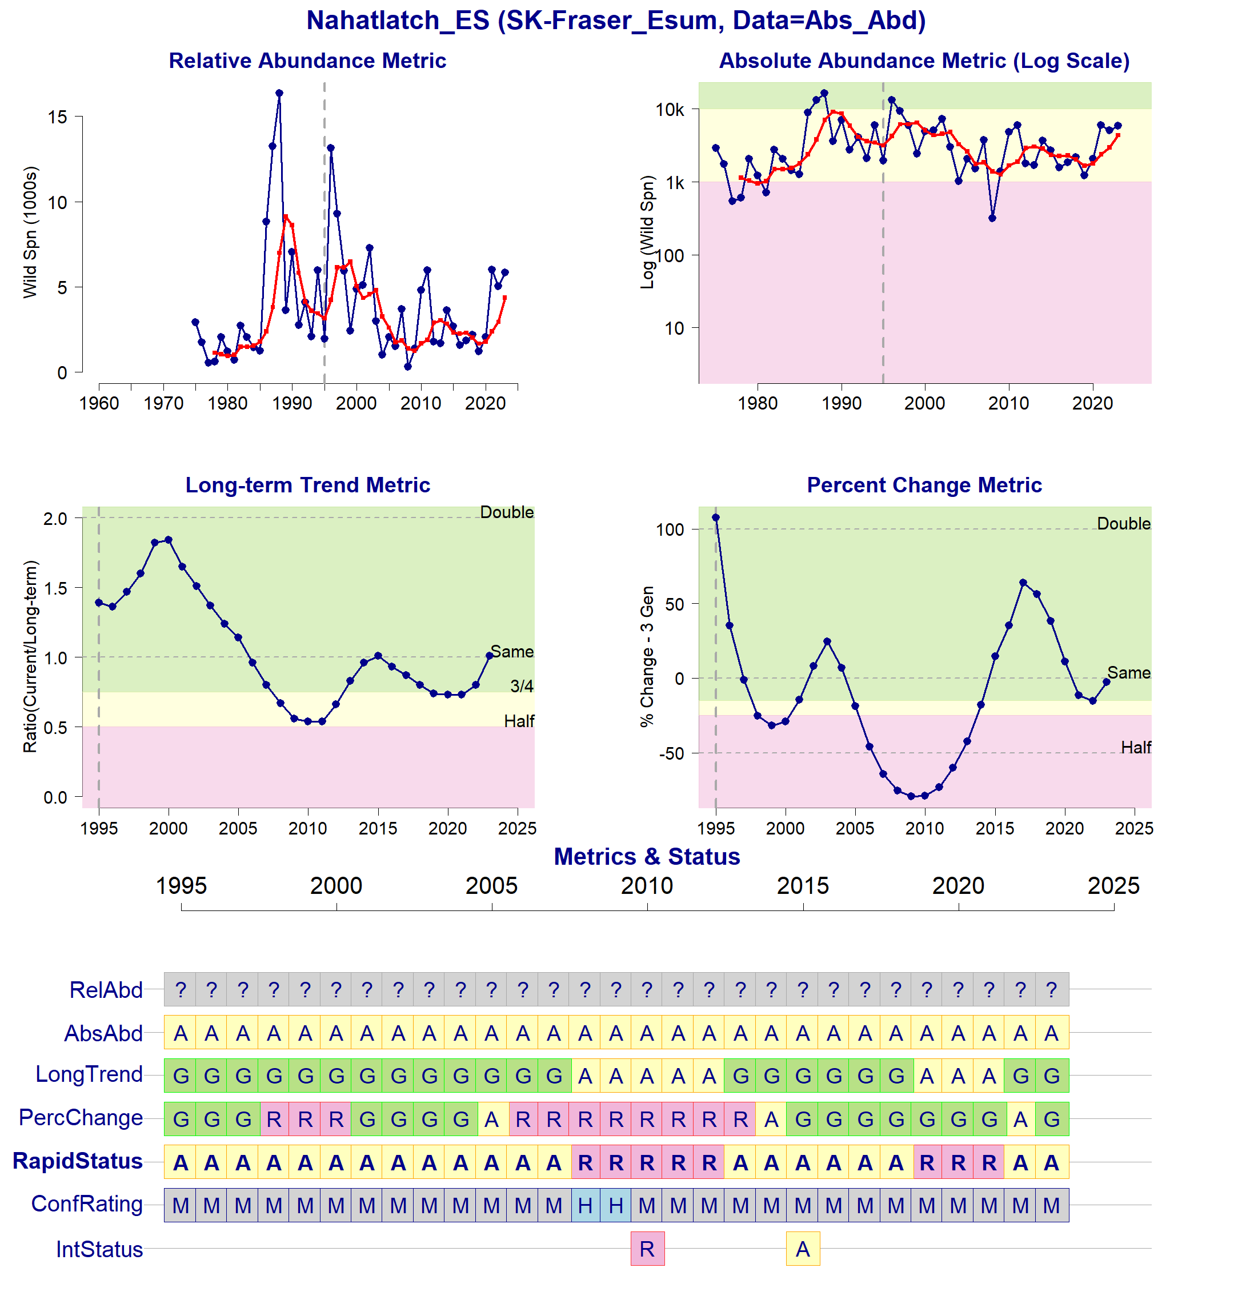
Figure 3: Metrics and Status for Nahatlatch-ES (SEL-05-02). Panels on top show the four standard WSP metrics, calculated based on the available time series of spawner abundances. There are no relative abundance benchmarks, so they cannot be indicated in the top left figure. Bottom panel summarizes the status for each individual metric and shows the resulting WSP rapid status for the CU with a confidence rating. If integrated WSP status assessments have been completed for this CU, they are shown on the last row (IntStatus). Note that metric benchmarks may differ from algorithm thresholds, since thresholds approximate the status determination process from past WSP integrated status assessments (see Figure 4 and Table 5).
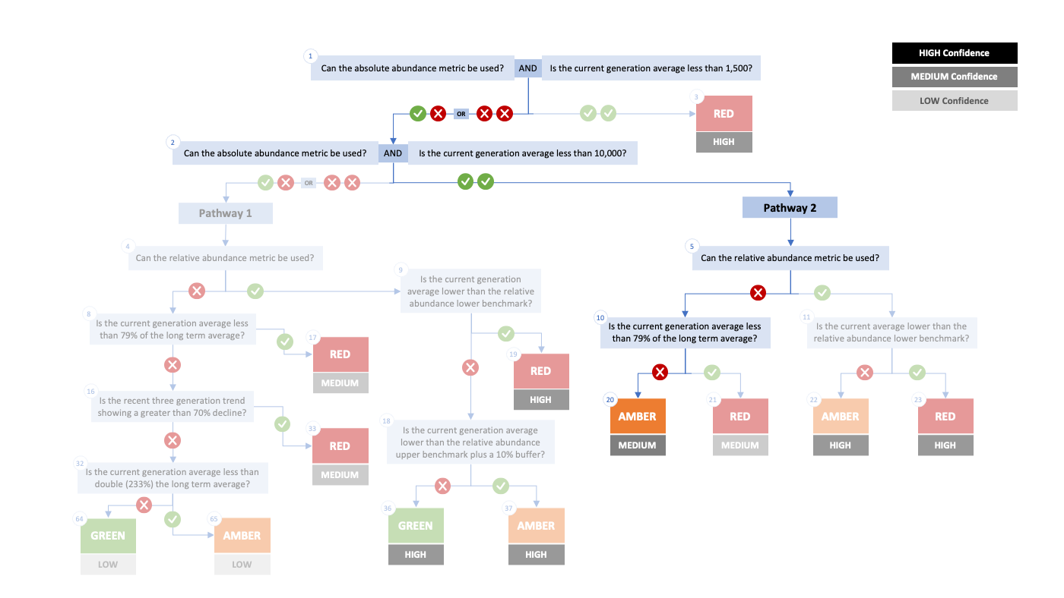
Figure 4. Algorithm pathway taken to assess status for the Nahatlatch-ES in 2023. The recent generational average falls above the absolute abundance lower (1,500) threshold (node 1), the current generation is <10,000 at node 2, the relative abundance metric can’t be used at node 5, and the current generational average is not <79% of the long term average . Status for this CU is therefore designated as Amber with Medium confidence at Node 20.
Table 5: Decision tree path given data and metric values for the Nahatlatch-ES in 2023; this aligns with Figure 4 above. For each node, the algorithm decision is made by comparing the CUs current metric value to the metric threshold and answering Yes or No, running through sequential nodes and decisions until the final WSP rapid status for that CU and year is reached.
Node | Metric | Metric Threshold | CU’s Current Value | Decision
1 | Absolute Abundance | <1,500 | 4,352 | YES, NO
2 | Absolute Abundance | <10,000 | 4,352 | YES, YES
5 | Relative Abundance | Available? |  | NO
10 | Absolute Abundance | <79% long term avg? |  | NO
20 | FINAL STATUS NODE |  |  | AMBER,MEDIUM

SEL-09-02 Shuswap-ES
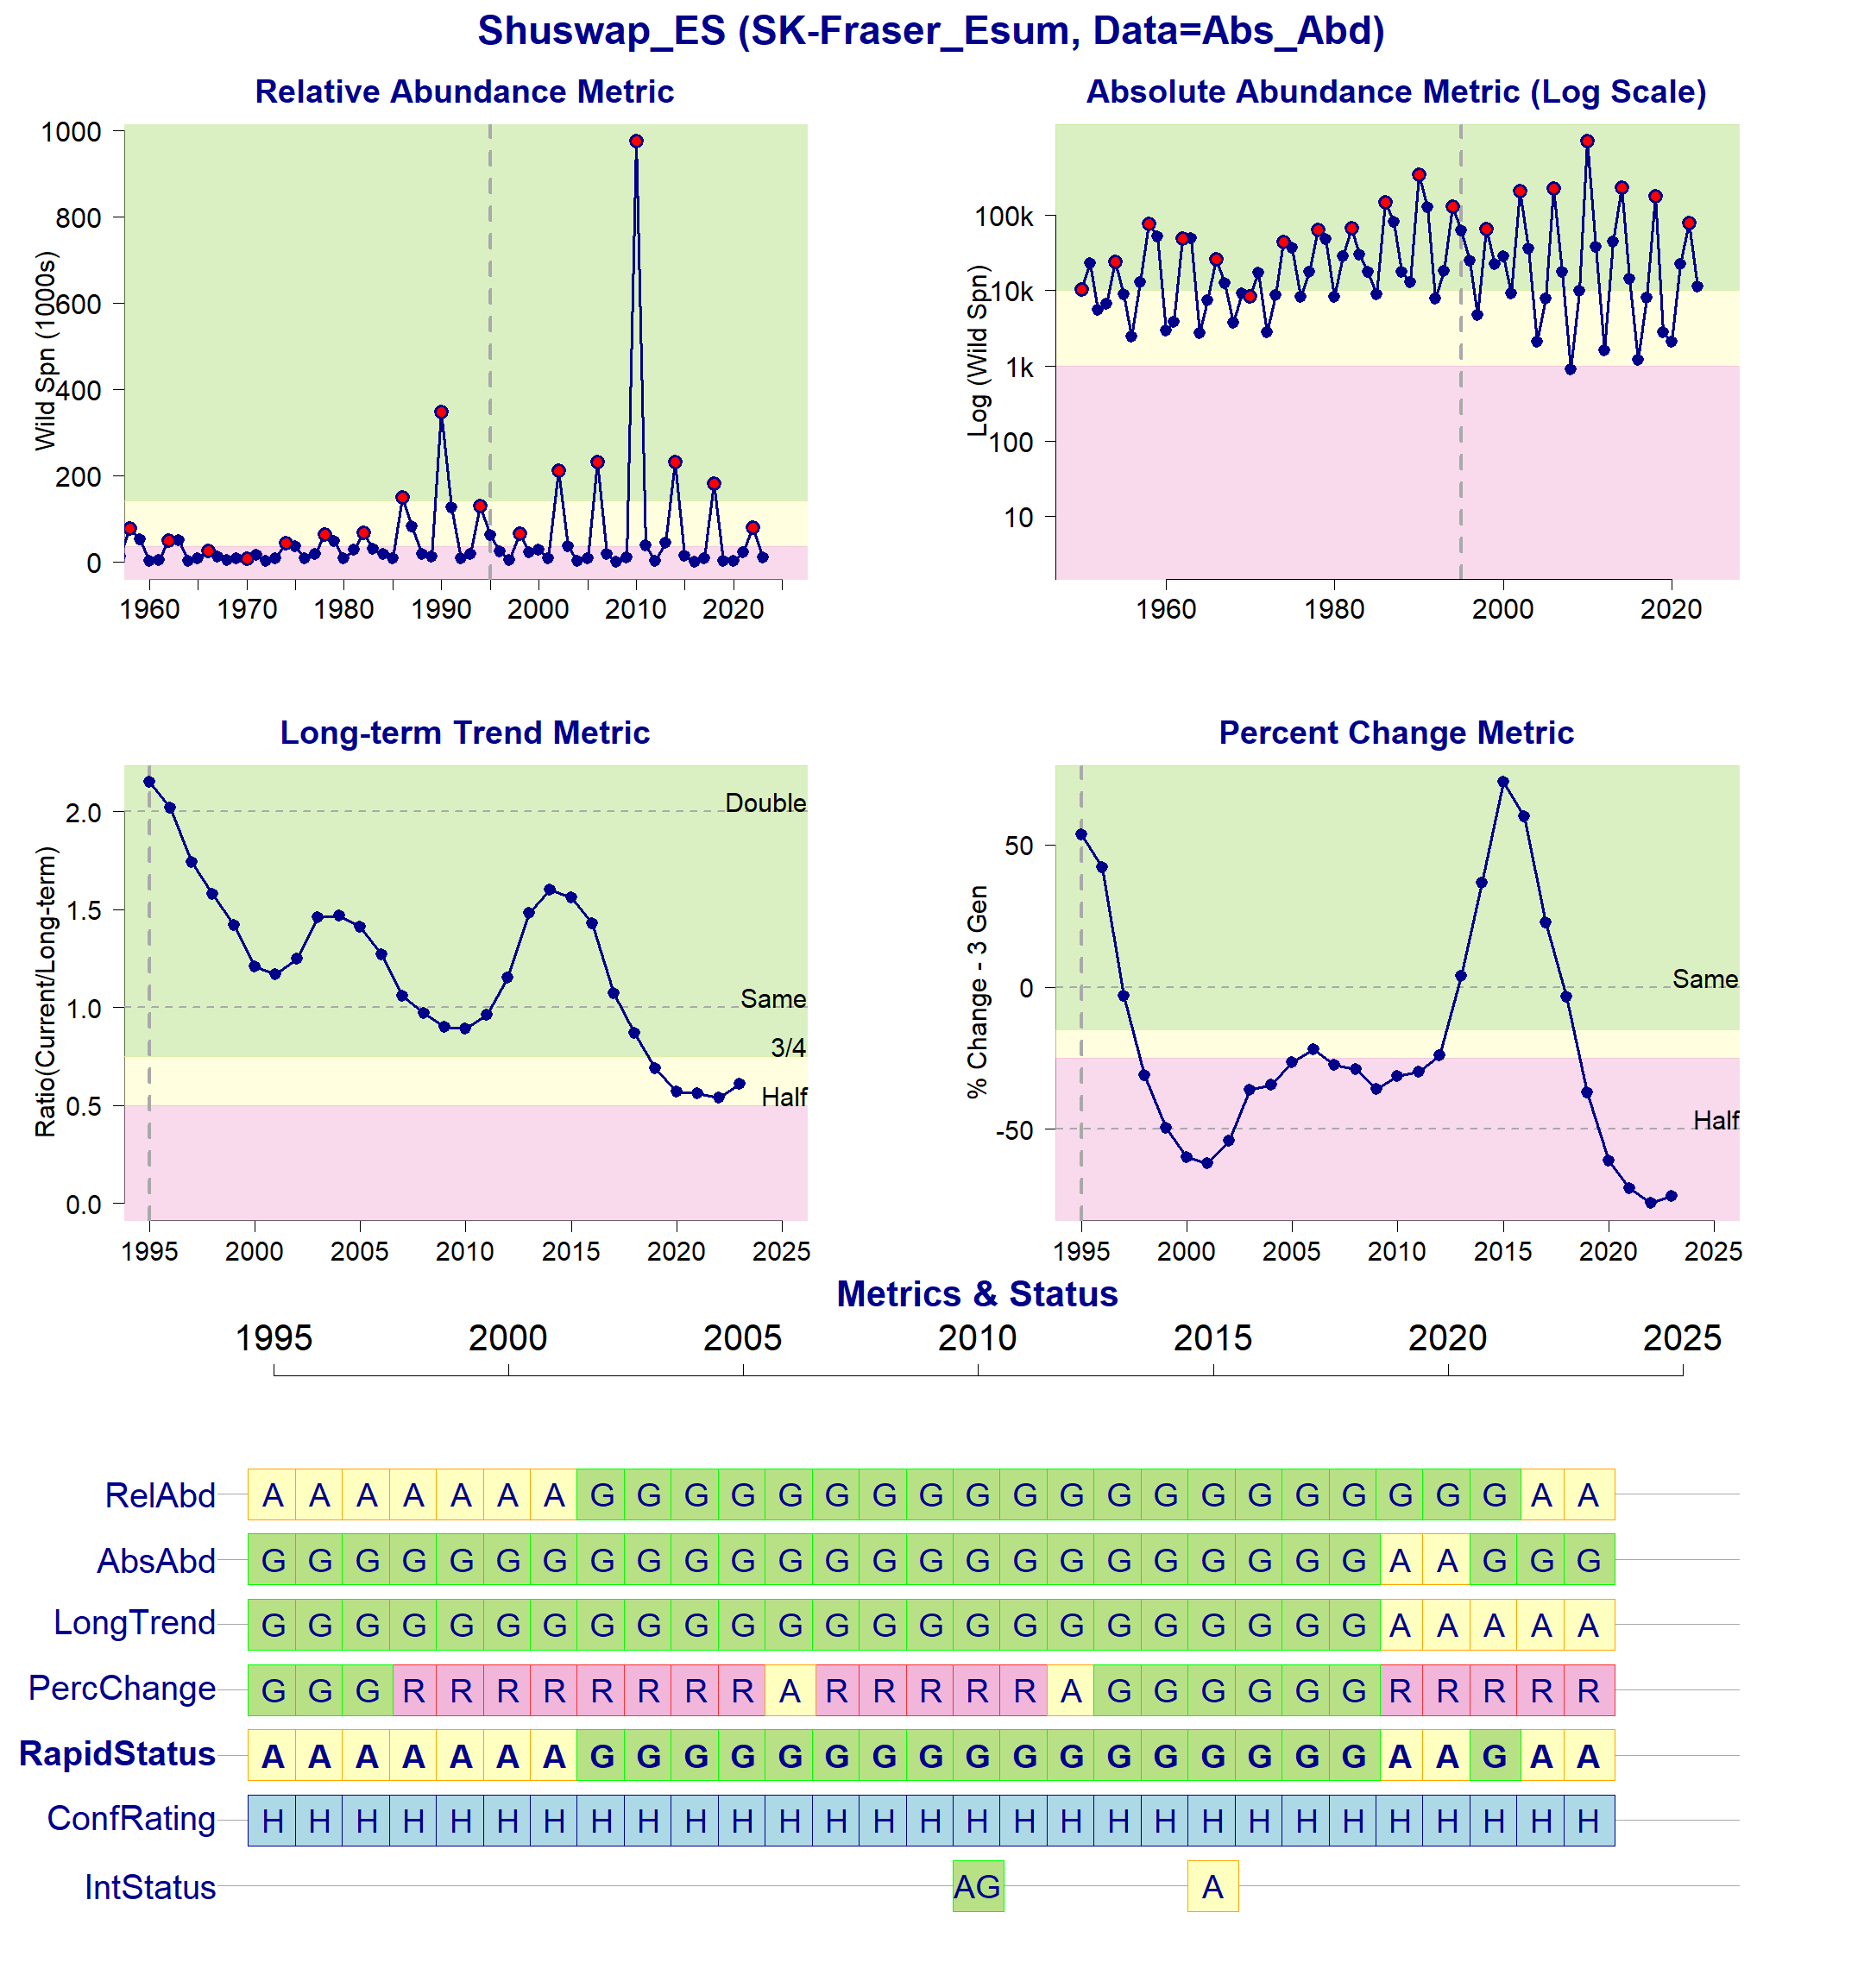
Figure 5: Metrics and Status for Shuswap-ES (SEL-09-02). Panels on top show the four standard WSP metrics, calculated based on the available time series of spawner abundances. There are no relative abundance benchmarks, so they cannot be indicated in the top left figure. Bottom panel summarizes the status for each individual metric and shows the resulting WSP rapid status for the CU with a confidence rating. If integrated WSP status assessments have been completed for this CU, they are shown on the last row (IntStatus). Note that metric benchmarks may differ from algorithm thresholds, since thresholds approximate the status determination process from past WSP integrated status assessments (see Figure 6 and Table 6).
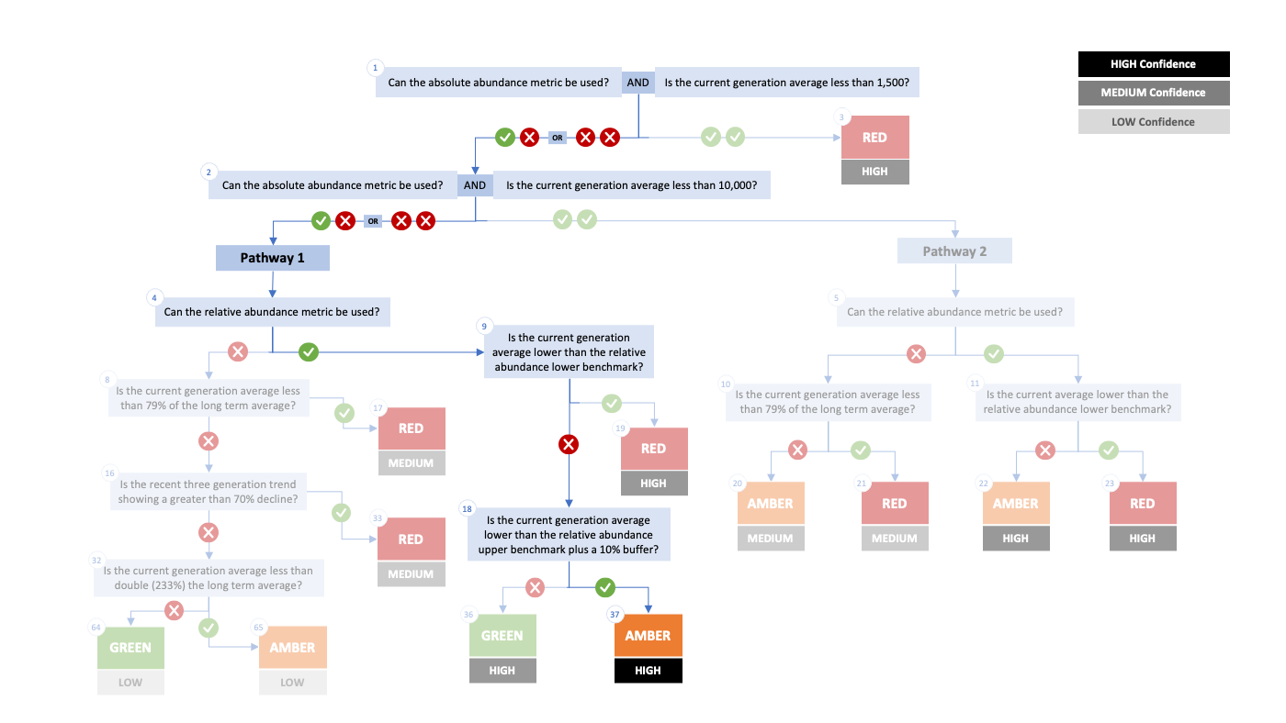
Figure 6. Algorithm pathway taken to assess status for the Shuswap-ES in 2023. The recent generational average falls above the absolute abundance upper (10,000) threshold (node 1-2) but below the relative abundance upper (nodes 4, 9, and 18). Status for this CU is therefore designated as Amber with High confidence at Node 37.
Table 6: Decision tree path given data and metric values for the Shuswap-ES in 2023; this aligns with Figure 6 above. For each node, the algorithm decision is made by comparing the CUs current metric value to the metric threshold and answering Yes or No, running through sequential nodes and decisions until the final WSP rapid status for that CU and year is reached.
Node | Metric | Metric Threshold | CU’s Current Value | Decision
1 | Absolute Abundance | <1,500 | 10,078 | YES, NO
2 | Absolute Abundance | <10,000 | 10,078 | YES, NO
4 | Relative Abundance | Available? | 79,625 | YES
9 | Relative Abundance | <36,380 | 79,625 | NO
18 | Relative Abundance | <155,921 | 79,625 | YES
37 | FINAL STATUS NODE | - | - | AMBER, HIGH

SEL-10-03 North Barriere-ES
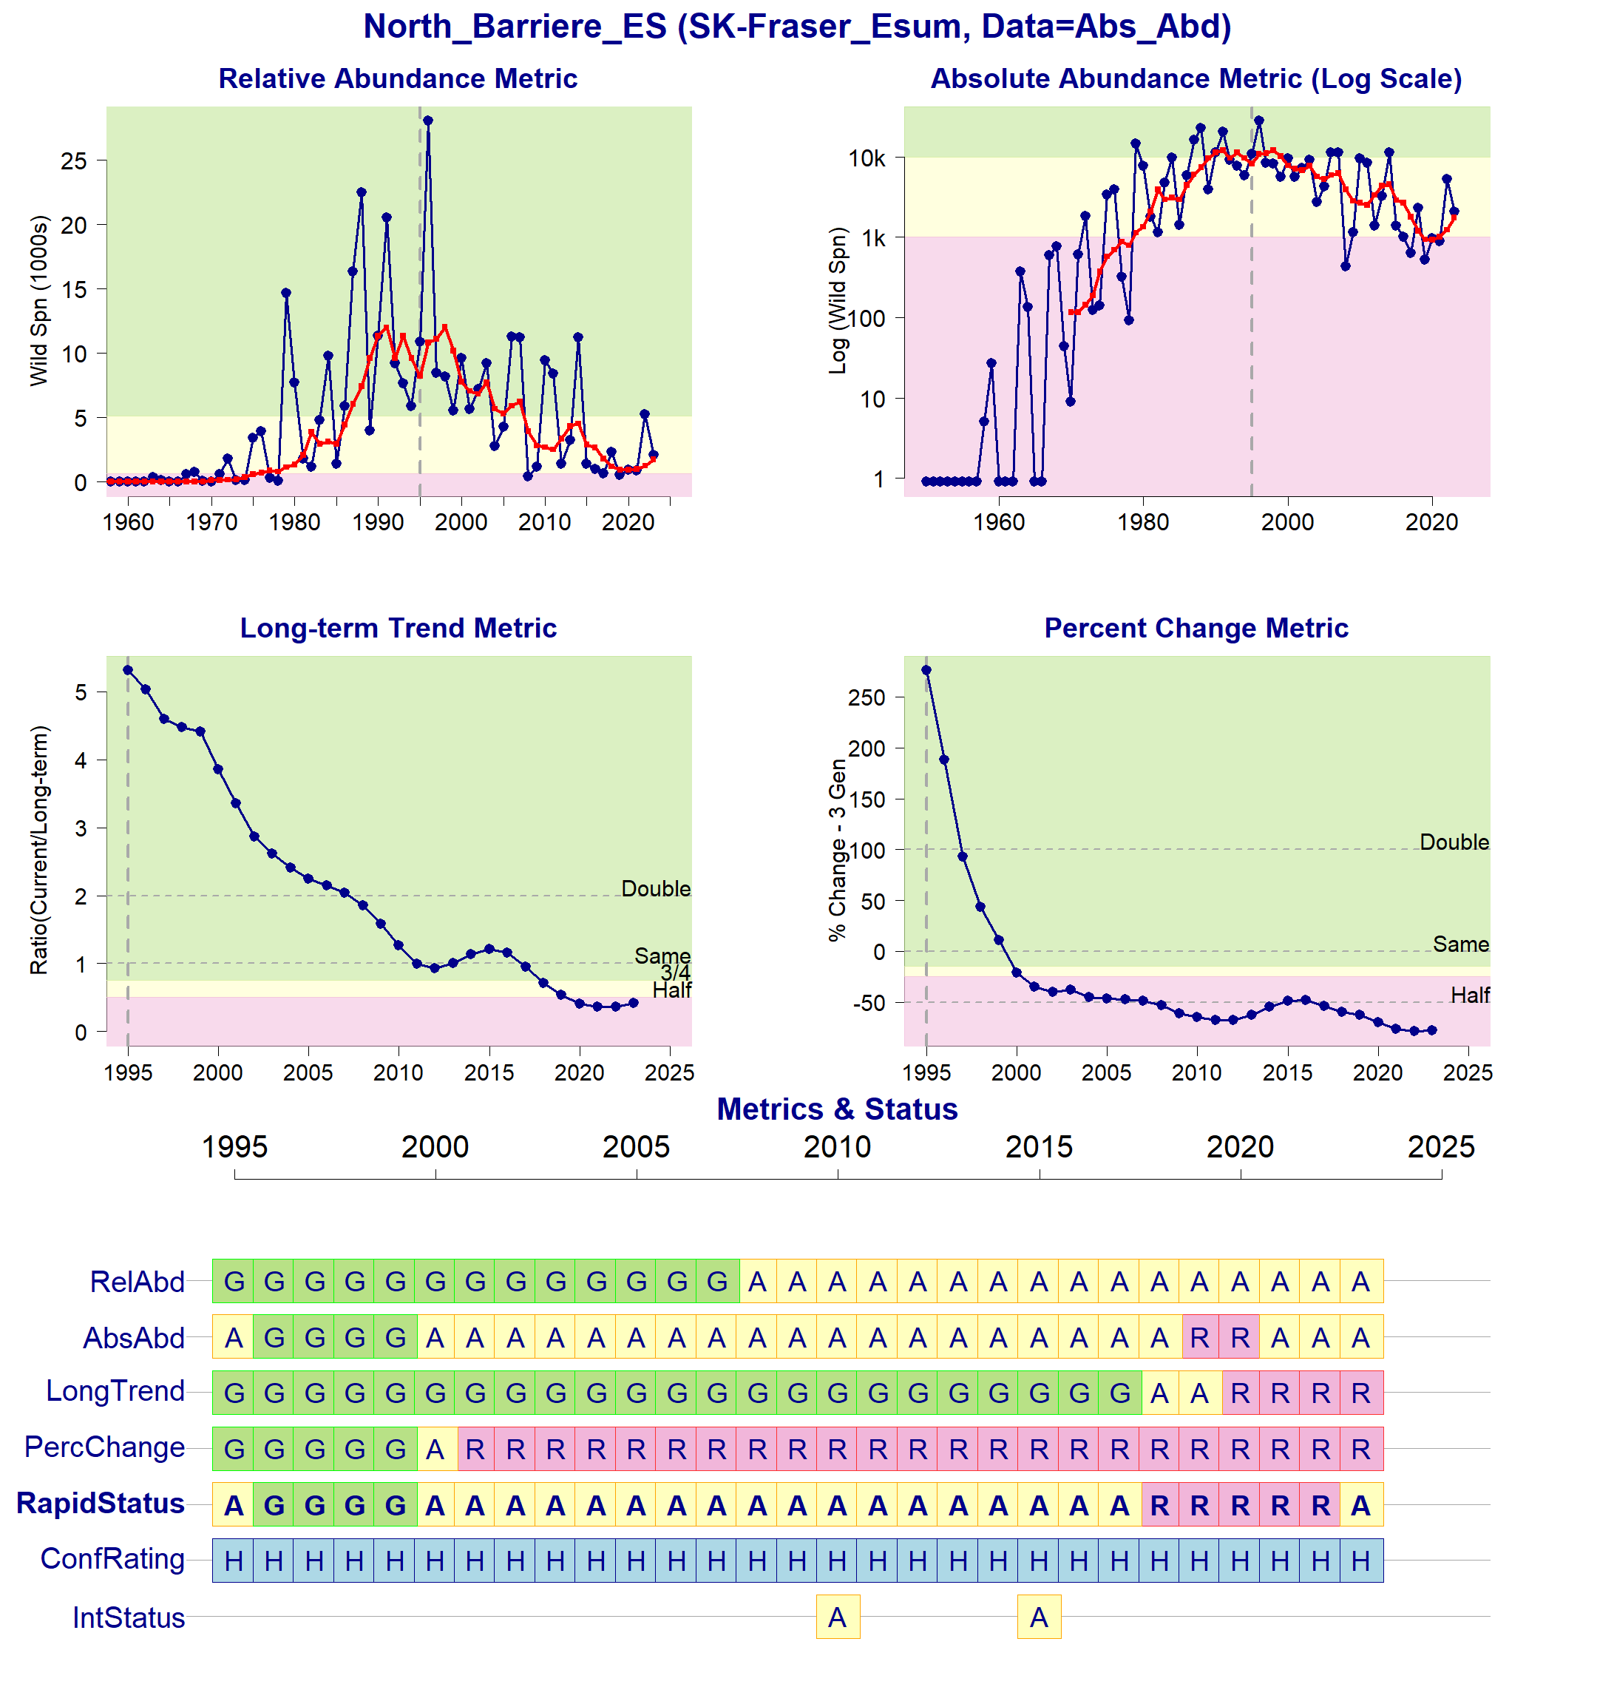
Figure 7: Metrics and Status for North Barriere-ES (SEL-10-03). Panels on top show the four standard WSP metrics, calculated based on the available time series of spawner abundances. There are no relative abundance benchmarks, so they cannot be indicated in the top left figure. Bottom panel summarizes the status for each individual metric and shows the resulting WSP rapid status for the CU with a confidence rating. If integrated WSP status assessments have been completed for this CU, they are shown on the last row (IntStatus). Note that metric benchmarks may differ from algorithm thresholds, since thresholds approximate the status determination process from past WSP integrated status assessments (see Figure 8 and Table 7).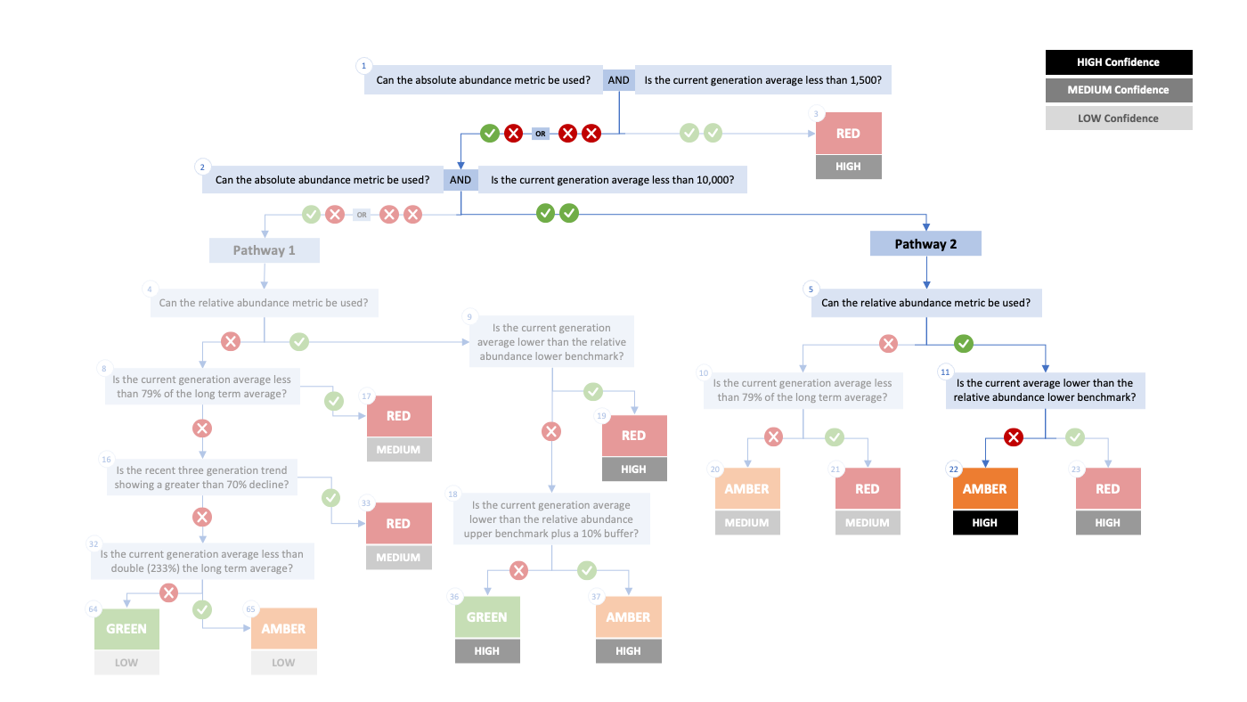
Figure 8. Algorithm pathway taken to assess status for the North Barriere-ES in 2023. The recent generational average is above the absolute abundance lower (1,500) threshold (node 1), the absolute abundance metric can be used and the current generational average is less than 10,000 (node 2). The relative abundance metric can be used and it is above the lower benchmark (640). Status for this CU is therefore designated as Amber with High confidence at Node 22.
Table 7: Decision tree path given data and metric values for the North Barriere-ES in 2023; this aligns with Figure 8 above. For each node, the algorithm decision is made by comparing the CUs current metric value to the metric threshold and answering Yes or No, running through sequential nodes and decisions until the final WSP rapid status for that CU and year is reached.
Node | Metric | Metric Threshold | CU’s Current Value | Decision
1 | Absolute Abundance | <1,500 | 1,740 | YES, NO
2 | Absolute Abundance | <10,000 | 1,740 | YES, YES
5 | Relative Abundance | Available? |  | YES
11 | Relative Abundance | <640 | 1,740 | NO
22 | FINAL STATUS NODE |  |  | AMBER, HIGH

SEL-03-01 Chilliwack-ES
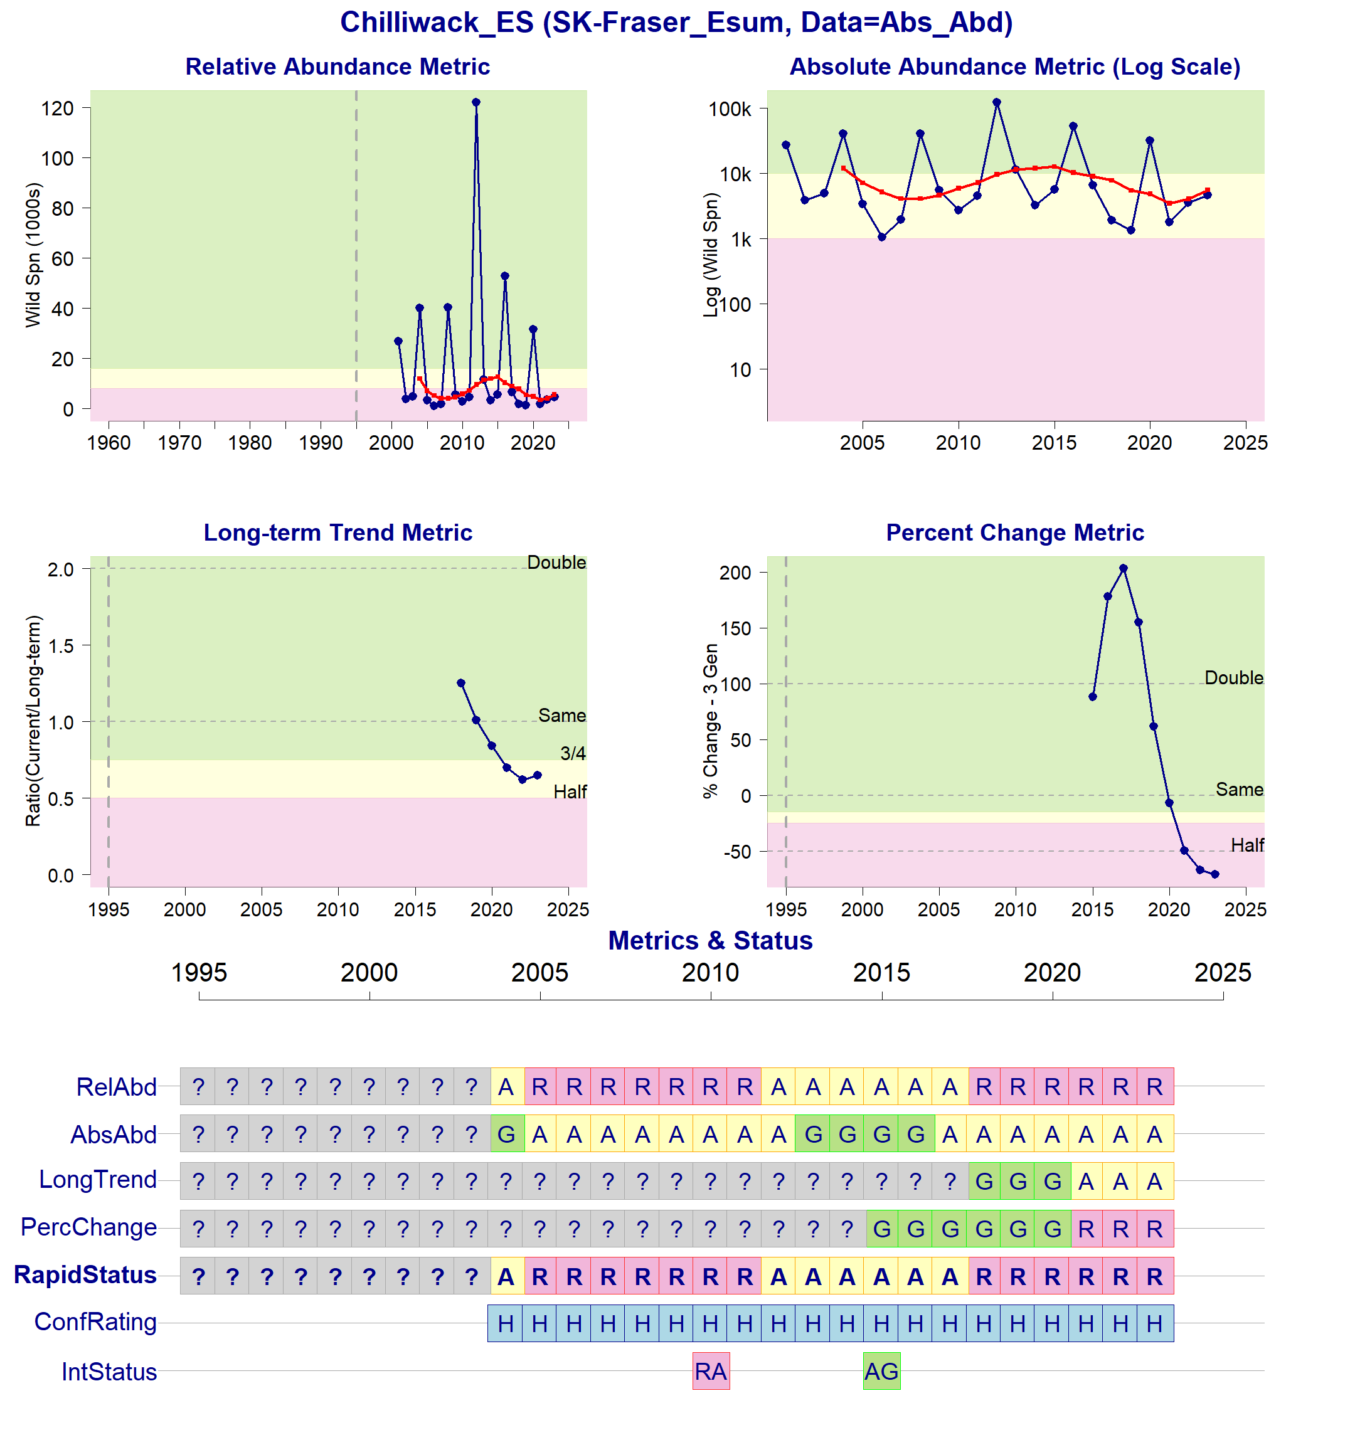
Figure 9: Metrics and Status for Chilliwack-ES (SEL-03-01). Panels on top show the four standard WSP metrics, calculated based on the available time series of spawner abundances. There are no relative abundance benchmarks, so they cannot be indicated in the top left figure. Bottom panel summarizes the status for each individual metric and shows the resulting WSP rapid status for the CU with a confidence rating. If integrated WSP status assessments have been completed for this CU, they are shown on the last row (IntStatus). Note that metric benchmarks may differ from algorithm thresholds, since thresholds approximate the status determination process from past WSP integrated status assessments (see Figure 10 and Table 8).
Figure 10. Algorithm pathway taken to assess status for the Chilliwack-ES in 2023. The recent generational average falls above the absolute abundance upper (10,000) threshold (node 1-2), the relative abundance metric can be used (node 5) and the current average is lower than the relative abundance lower benchmark (8,000; node 11). Status for this CU is therefore designated as Red with High confidence at Node 23.
Table 8: Decision tree path given data and metric values for the Chilliwack-ES (SEL-03-01) in 2023; this aligns with Figure 10 above. For each node, the algorithm decision is made by comparing the CUs current metric value to the metric threshold and answering Yes or No, running through sequential nodes and decisions until the final WSP rapid status for that CU and year is reached.
Node | Metric | Metric Threshold | CU’s Current Value | Decision
1 | Absolute Abundance | <1,500 | 5,536 | YES, NO
2 | Absolute Abundance | <10,000 | 5,536 | YES, YES
5 | Relative Abundance | Available? | - | YES
11 | Relative Abundance | <8,000 | 5,536 | YES
23 | FINAL STATUS NODE | - | - | RED, HIGH

SEL-06-01 Anderson-Seton-ES
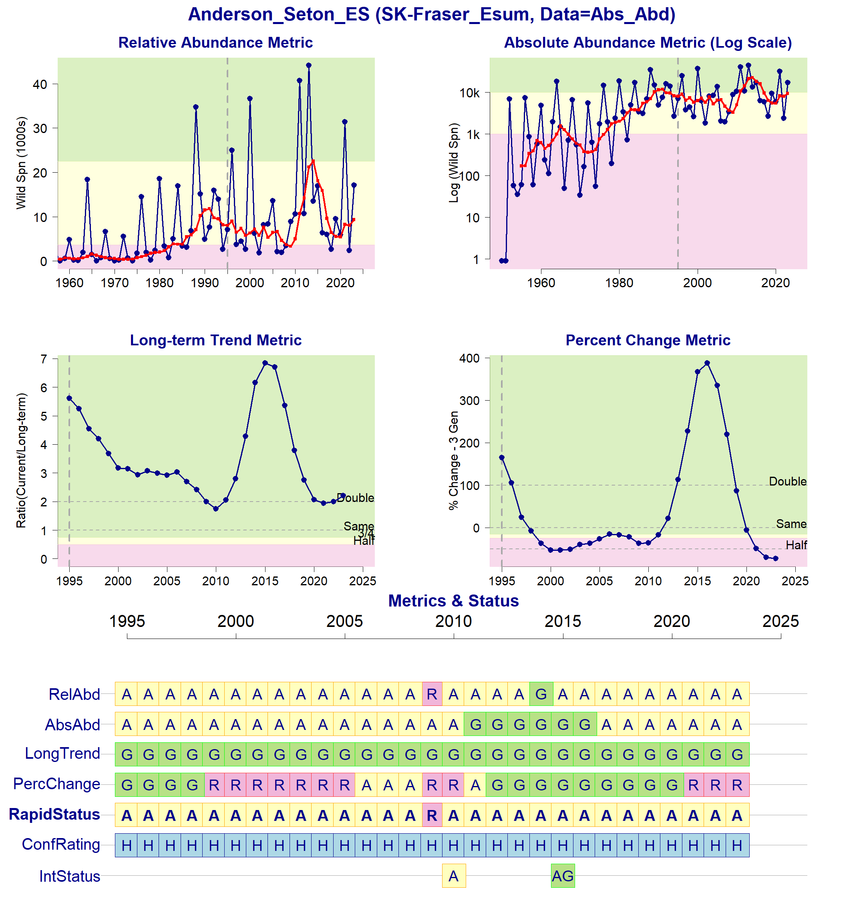
Figure 11: Metrics and Status for Anderson-Seton-ES (SEL-06-01). Panels on top show the four standard WSP metrics, calculated based on the available time series of spawner abundances. There are no relative abundance benchmarks, so they cannot be indicated in the top left figure. Bottom panel summarizes the status for each individual metric and shows the resulting WSP rapid status for the CU with a confidence rating. If integrated WSP status assessments have been completed for this CU, they are shown on the last row (IntStatus). Note that metric benchmarks may differ from algorithm thresholds, since thresholds approximate the status determination process from past WSP integrated status assessments (see Figure 12 and Table 9).
Figure 12. Algorithm pathway taken to assess status for the Anderson-Seton-ES in 2023. The recent generational average falls above the absolute abundance upper (10,000) threshold (node 1-2), the relative abundance metric can be used (node 5) and the current average is higher than the relative abundance lower benchmark (3,662; node 11) Status for this CU is therefore designated as Amber with High confidence at Node 22.
Table 9: Decision tree path given data and metric values for the Anderson-Seton-ES (SEL-06-01) in 2023; this aligns with Figure 12 above. For each node, the algorithm decision is made by comparing the CUs current metric value to the metric threshold and answering Yes or No, running through sequential nodes and decisions until the final WSP rapid status for that CU and year is reached.
Node | Metric | Metric Threshold | CU’s Current Value | Decision
1 | Absolute Abundance | <1,500 | 9,330 | YES, NO
2 | Absolute Abundance | <10,000 | 9,330 | YES, YES
5 | Relative Abundance | Available? | - | YES
11 | Relative Abundance | <3,662 | 9,330 | NO
22 | FINAL STATUS NODE | - | - | AMBER, HIGH

SEL-06-20 Nadina-Francois-ES
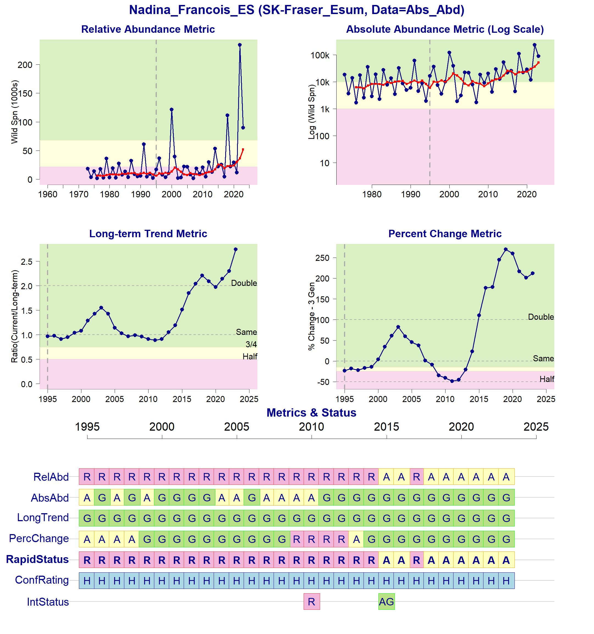
Figure 13: Metrics and Status for Nadina Francois-ES (SEL-06-20). Panels on top show the four standard WSP metrics, calculated based on the available time series of spawner abundances. There are no relative abundance benchmarks, so they cannot be indicated in the top left figure. Bottom panel summarizes the status for each individual metric and shows the resulting WSP rapid status for the CU with a confidence rating. If integrated WSP status assessments have been completed for this CU, they are shown on the last row (IntStatus). Note that metric benchmarks may differ from algorithm thresholds, since thresholds approximate the status determination process from past WSP integrated status assessments (see Figure 14 and Table 10).
Figure 14. Algorithm pathway taken to assess status for the Nadina Francois-ES in 2023. The recent generational average falls above the absolute abundance upper (10,000) threshold (node 1-2) but below the relative abundance upper (nodes 4, 9, and 18). Status for this CU is therefore designated as Amber with High confidence at Node 37.
Table 10: Decision tree path given data and metric values for the Nadina Francois-ES in 2023; this aligns with Figure 14 above. For each node, the algorithm decision is made by comparing the CUs current metric value to the metric threshold and answering Yes or No, running through sequential nodes and decisions until the final WSP rapid status for that CU and year is reached.
Node | Metric | Metric Threshold | CU’s Current Value | Decision
1 | Absolute Abundance | <1,500 | 51,856 | YES, NO
2 | Absolute Abundance | <10,000 | 51,856 | YES, NO
4 | Relative Abundance | Available? |  | YES
9 | Relative Abundance | <21,694 | 51,856 | NO
18 | Relative Abundance | <75,100 | 51,856 | YES
37 | FINAL STATUS NODE | - | - | AMBER, HIGH

SEL-03-05 Pitt-ES
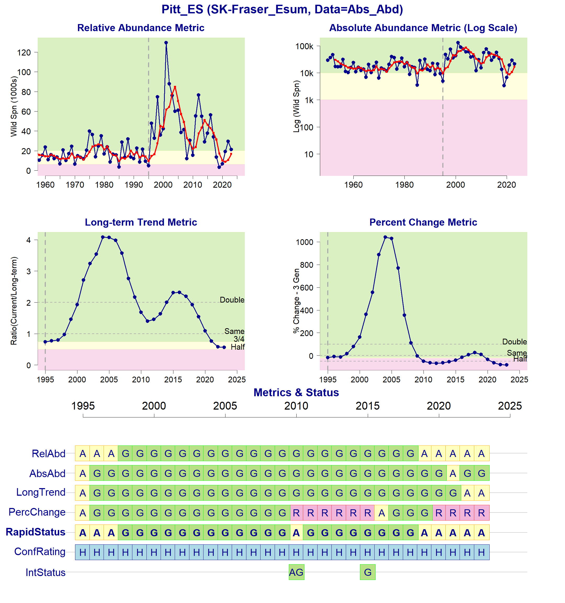
Figure 15: Metrics and Status for Pitt-ES (SEL-03-05). Panels on top show the four standard WSP metrics, calculated based on the available time series of spawner abundances. There are no relative abundance benchmarks, so they cannot be indicated in the top left figure. Bottom panel summarizes the status for each individual metric and shows the resulting WSP rapid status for the CU with a confidence rating. If integrated WSP status assessments have been completed for this CU, they are shown on the last row (IntStatus). Note that metric benchmarks may differ from algorithm thresholds, since thresholds approximate the status determination process from past WSP integrated status assessments (see Figure 16 and Table 11).
Figure 16. Algorithm pathway taken to assess status for the Pitt-ES in 2023. The recent generational average falls above the absolute abundance upper (10,000) threshold (node 1-2) but below the relative abundance upper (nodes 4, 9, and 18). Status for this CU is therefore designated as Amber with High confidence at Node 37.
Table 11 : Decision tree path given data and metric values for the Pitt-ES in 2023; this aligns with Figure 16 above. For each node, the algorithm decision is made by comparing the CUs current metric value to the metric threshold and answering Yes or No, running through sequential nodes and decisions until the final WSP rapid status for that CU and year is reached.
Node | Metric | Metric Threshold | CU’s Current Value | Decision
1 | Absolute Abundance | <1,500 | 16,897 | YES, NO
2 | Absolute Abundance | <10,000 | 16,897 | YES, NO
4 | Relative Abundance | Available? |  | YES
9 | Relative Abundance | <6,240 | 16,897 | NO
18 | Relative Abundance | <22,366 | 16,897 | YES
37 | FINAL STATUS NODE | - | - | AMBER, HIGH

SEL-06-16 Taseko-ES
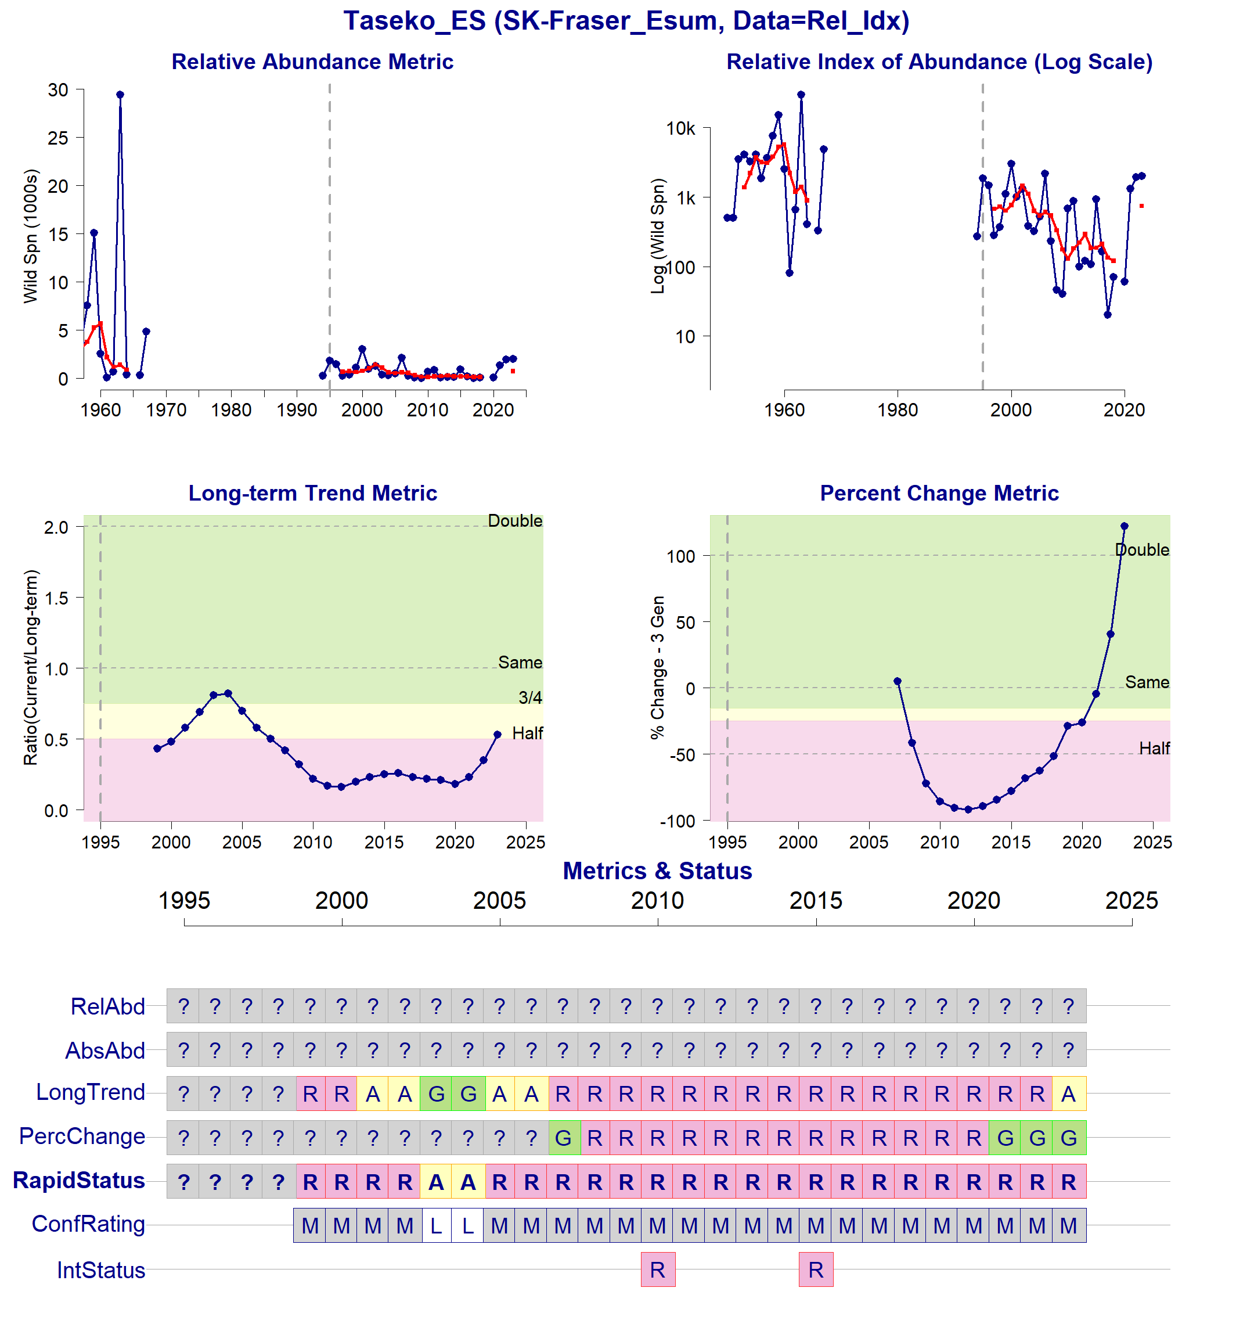
Figure 17: Metrics and Status for Taseko-ES (SEL-06-16). Panels on top show the four standard WSP metrics, calculated based on the available time series of spawner abundances. There are no relative abundance benchmarks, so they cannot be indicated in the top left figure. Bottom panel summarizes the status for each individual metric and shows the resulting WSP rapid status for the CU with a confidence rating. If integrated WSP status assessments have been completed for this CU, they are shown on the last row (IntStatus). Note that metric benchmarks may differ from algorithm thresholds, since thresholds approximate the status determination process from past WSP integrated status assessments.

Cited and other Key References
DFO. 2005. Canada’s Policy for Conservation of Wild Pacific Salmon. Fisheries and Oceans Canada, Vancouver, B.C., pp. vi+ 49.
DFO. 2009. A Fishery Decision-Making Framework Incorporating the Precautionary Approach.
DFO. 2022. Methodologies and guidelines for defining limit reference points for Pacific Salmon. CSAS SAR 2022/030. pp. 16.
DFO. 2023. Science advice on guidance for limit reference points under the Fish Stocks provisions. DFO Can. Sci. Advis. Sec. Sci. Advis. Rep. 2023/009.
DFO 2024. Rapid status approximations for Pacific salmon derived from integrated status assessments under DFO’s Wild Salmon Policy. CSAS Sci. Resp. 2024/004.
Grant, S.C.H., MacDonald, B.L., and Winston, M.L. 2019. State of the Canadian Pacific salmon: responses to changing climate and habitats. Can. Tech. Rep. Fish. Aquat. Sci. 3332: ix + 50 pp. Available from http://www.dfo-mpo.gc.ca/species-especes/publications/salmon-saumon/state-etat-2019/abstract-resume/index-eng.html
Holt, C.A., Cass, A., Holtby, B., and Riddell, B. 2009. Indicators of status and benchmarks for Conservation Units in Canada’s Wild Salmon Policy. Can. Sci. Advis. Sec. Res. Doc. 2009/058: viii + 74.
Holt, C.A., Holt, K., Wor, C., Warkentin, L., Connors, B., Grant, S.C.H., and Huang, A.-M. 2023a. Guidelines for Defining Limit Reference Points for Pacific Salmon Stock Management Units. Can. Sci. Adv. Sec. Res. Doc. 2023/009: iv + 66.
Holt, K., Holt, C.A., Warkentin, L., Wor, C., Davis, B., Arbeider, M., Bokvist, J., Crowley, S., Grant, S.C.H., Luedke, W., McHugh, D., Picco, C., and Will, P. Van. 2023b. Case Study Applications of LRP Estimation Methods to Pacific Salmon Stock Management Units. Can. Sci. Advis. Sec. Res. Doc. 2023/010: iv + 129.
Holt, C.A., and Irvine, J.R. 2013. Distinguishing benchmarks of biological status from management reference points: a case study on Pacific salmon in Canada. Environ. Conserv. 40 (4): 345–355. doi:https://doi.org/10.1017/S0376892913000209
Holtby, B.L., and Ciruna, K.A. 2007. Conservation units for Pacific salmon under the Wild Salmon Policy. Can. Sci. Advis. Sec. Res. Doc. 2007/070: viii + 350 pp. Available from http://www.dfo-mpo.gc.ca/csas-sccs/publications/resdocs-docrech/2007/2007_070-eng.htm
Pestal, G., MacDonald, B.L., Grant, S.C.H., and Holt, C.A. 2023. State of the Salmon: rapid status assessment approach for Pacific salmon under Canada’s Wild Salmon Policy. Can. Tech. Rep. Fish. Aquat. Sci. 3570: xiv + 200 p.
Pestal, G., MacDonald, B.L., Grant, S.C.H., and Carr-Harris, C. 2024. State of the Salmon: Wild Salmon Policy rapid status approach for Fraser, Skeena, and Nass sockeye, Fraser pink and chum, Interior Fraser Coho, and southern BC Chinook salmon. Can. Tech. Rep. Fish. Aquat. Sci. (in Prep).

Appendix A: WSP rapid status approach details

The decision tree sequence is as follows (see Figure A1; Table A1, A2):
- The first question is whether or not a CU has a current absolute abundance value, and if so, whether or not this value falls below the lower threshold of 1,500 (which adds a buffer to Committee on the Status of Endangered Wildlife in Canada (COSEWIC) Criterion D1 for small population size of 1,000). If the answer to this question is Yes, then the CU is assigned Red (node 3), with High confidence.
- If the answer to the first question is No, then the second question is whether or not the CU has a current absolute abundance value, and if so, whether or not the current abundance is below the upper threshold of 10,000, which is COSEWIC's Criterion C upper benchmark. This second question splits the decision nodes into two Pathways: Pathway 1 (No to this question) and Pathway 2 (Yes to this question).
  - Pathway 1: is where a CU either does not have a current absolute abundance value, or has these data, and it falls above the upper threshold for this metric. This pathway is split with the question: can this CU be assessed with a relative abundance metric. If the answer is Yes, a Red (nodes 19), Amber (nodes 37) or Green (node 36) WSP rapid status is assigned, with High confidence, depending on where the current abundance value falls relative to this metric’s lower and upper thresholds. If the answer is NO, then comparisons are made between the CU’s current abundances and percent change to thresholds for these metrics, which assign a Red with Medium confidence, or Green or Amber with Low confidence status.
  - Pathway 2: is where a CU has absolute abundance data, and these abundances fall between the lower and upper thresholds. In this pathway, absolute abundances restrict WSP rapid statuses to only Amber or Red. This pathway is split with the question: can this CU be assessed with a relative abundance metric. If the answer is Yes, an Amber (node 22) with Medium confidence, or Red (node 23) with High confidence, is assigned, depending on whether the CU’s current abundance value falls above the relative abundance metric lower threshold or below. If the CU cannot be assessed with a relative abundance metric, then it is compared to the lower threshold of the Long-Term trend metric and assigned Amber (node 20) with Medium confidence if above, or Red (node 21) with Medium confidence if below.

Table A1. Biological status zones under the Wild Salmon Policy (WSP).

Status |  | Definition
 | Red | Poor status CU facing an imminent threat of extinction [revised definition, given alignment with COSEWIC Endangered statuses]
 | Amber | “While a CU in the Amber zone should be at low risk of loss, there will be a degree of lost production. Still, this situation may results when CUs share risk factors with other, more productive units”. Aligns with COSEWIC Threatened and Special Concern statuses.
 | Green | “identif[ies] whether harvest are greater than the level expected to provide on an average annual basis, the maximum annual catch for a CU, given existing conditions…there would not be a high probability of losing the CU”. Aligns with COSEWIC Not at Risk statuses.
 | DD | Data deficient. CUs have been designated as DD if there is no data available, or if the available data is insufficient for calculating status metrics (after quality control).

Table A2. WSP rapid status Learning Tree 3 status assignments by node (see Figure 1). This table presents the decisions in Learning Tree 3 that led to Red or Amber or Green status assignments; status outcomes depend on the pathway and decisions made. The final node that corresponds to the status assignment is presented below (see Figure 1).
Node | Status | Rule
Node3 | Red | Data Type is Absolute Abundance AND Absolute Abundance < 1,500
Node17 | Red | Data Type is Relative Index OR Absolute Abundance ≥ 1,500;  then Data Type is Relative Index OR Absolute Abundance ≥ 10,000;  then no Relative Abundance lower benchmark; then Long Term Trend < 79%
Node19 | Red | Data Type is Relative Index OR Absolute Abundance ≥ 1,500;  then Data Type is Relative Index OR Absolute Abundance ≥ 10,000  then have Relative Abundance lower benchmark;  then Relative Abundance < Relative Abundance lower benchmark
Node20 | Amber | Data Type is Relative Index OR Absolute Abundance ≥ 1,500;  then Data Type is Absolute Abundance AND Absolute Abundance<10,000;  then no Relative Abundance lower benchmark; then Long Term Trend ≥ 79%
Node21 | Red | Data Type is Relative Index OR Absolute Abundance ≥ 1,500;  then Data Type is Absolute Abundance AND Absolute Abundance<10,000;  then no Relative Abundance lower benchmark; then Long Term Trend < 79%
Node22 | Amber | Data Type is Relative Index OR Absolute Abundance ≥ 1,500;  then Data Type is Absolute Abundance AND Absolute Abundance<10,000;  then have Relative Abundance lower benchmark;  then Relative Abundance ≥ Relative Abundance lower benchmark
Node23 | Red | Data Type is Relative Index OR Absolute Abundance ≥ 1,500;  then Data Type is Absolute Abundance AND Absolute Abundance<10,000;  then have Relative Abundance lower benchmark;  then Relative Abundance < Relative Abundance lower benchmark
Node33 | Red | Data Type is Relative Index OR Absolute Abundance ≥ 1,500;  then Data Type is Relative Index OR Absolute Abundance ≥ 10,000;  then no Relative Abundance lower benchmark;  then Long Term Trend ≥ 79%; then Percent Change < -70
Node36 | Green | Data Type is Relative Index OR Absolute Abundance ≥ 1,500;  then Data Type is Relative Index OR Absolute Abundance ≥ 10,000  then have Relative Abundance lower benchmark;  then Relative Abundance ≥ Relative Abundance lower benchmark;  then Relative Abundance ≥ Relative Abundance upper benchmark x 1.1
Node37 | Amber | Data Type is Relative Index OR Absolute Abundance ≥ 1,500;  then Data Type is Relative Index OR Absolute Abundance ≥ 10,000  then have Relative Abundance lower benchmark;  then Relative Abundance ≥ Relative Abundance lower benchmark;  then Relative Abundance < Relative Abundance upper benchmark x 1.1
Node64 | Green | Data Type is Relative Index OR Absolute Abundance ≥ 1,500;  then Data Type is Relative Index OR Absolute Abundance ≥ 10,000;  then no Relative Abundance lower benchmark;  then Long Term Trend ≥ 79%; then Percent Change < -70  then Long Term Trend ≥ 233
Node65 | Amber | Data Type is Relative Index OR Absolute Abundance ≥ 1,500;  then Data Type is Relative Index OR Absolute Abundance ≥ 10,000;  then no Relative Abundance lower benchmark;  then Long Term Trend ≥ 79%;  then Percent Change < -70  then Long Term Trend < 233

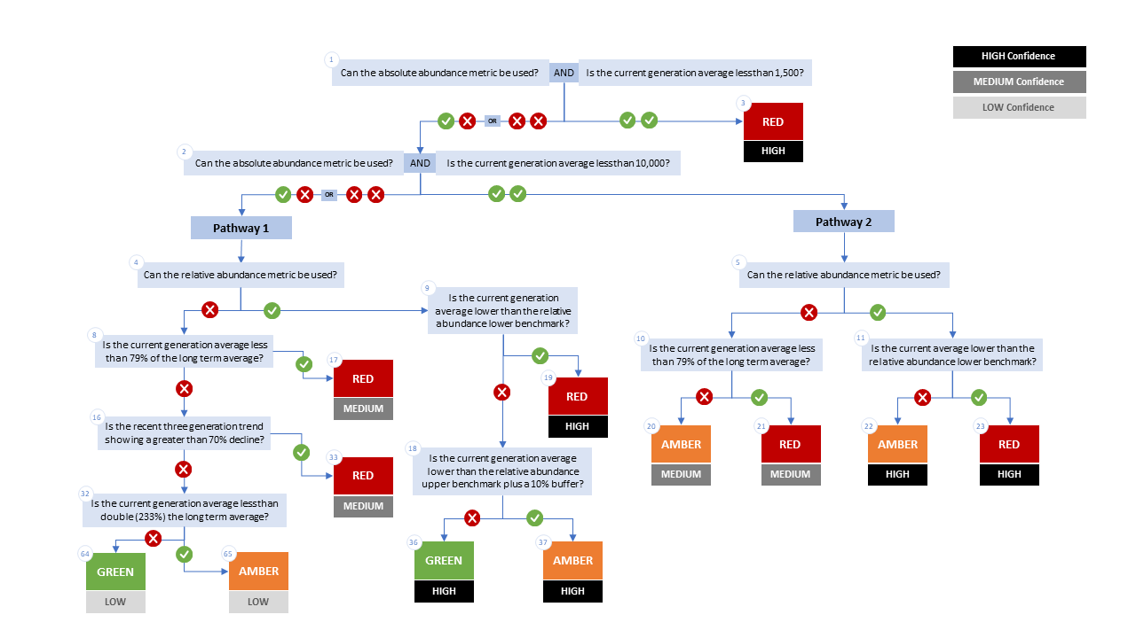

Figure A1. WSP rapid status decision tree (Table 2 includes written descriptions). To assess a CU, metric values are compared to thresholds presented at each decision point. Yes or No answers split each path of the decision tree, terminating at WSP rapid status assignments. The different splits are identified as nodes: 1 to 65. Pathway 1 is taken when the CU has no absolute abundance data, or these data exist, but fall above its upper threshold of 10,000. Pathway 2 is taken when the CU has absolute abundance data and these fall under its upper benchmark of 10,000.

Appendix B: Meeting History and Participants
Tables and summaries of meetings and participants, specifically participants who identified as a subject matter expert for one or more CUs.
Table B1. Meeting participants for the review of the 2022/23 Wild Salmon Policy Rapid Status Scanner for Fraser Pink, Chum and Sockeye. Meeting took place on January 8, 2025.
Kaitlyn Dionne | Fraser and Interior Stock Assessment, DFO
Michael Arbeider | Fraser and Interior Stock Assessment, DFO
Chuck Parken | Fraser and Interior Stock Assessment, DFO
Colin Bailey | Fraser and Interior Stock Assessment, DFO
Sue Grant | Science, DFO
Isabella Borea | Fraser and Interior Stock Assessment, DFO
Marissa Glavas | Fraser and Interior Stock Assessment, DFO
Scott Decker | Fraser and Interior Stock Assessment, DFO
Matthew Townsend | Fraser and Interior Stock Assessment, DFO
Kelsey Campbell | Upper Fraser Fisheries Commission
Pete Nicklin | Tsilqotin National Government
Elinor McGrath | Okanagan Nation Alliance
Chad Fuller | Okanagan Nation Alliance
Michelle Walsh | Secwepmec Fisheries Commission
Maxine Bruce | Lil’wat First Nation

Consensus: general agreement of group as a whole, or absence of evidence-based opposition to conclusions. Determined by the “weight of evidence” (scientific data, information, and analysis ) where multiple results are reported. In the event of disagreements, equally plausible conclusions can be reported. Dissenting views must be clearly described in the narrative.

